Broadband TechnologY CORP
4414 82nd Street
Suite 212
Lubbock, TX 79424

AND

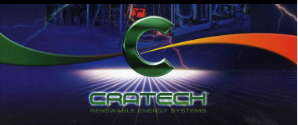
Teaming Partner CRATECH

SOURCES SOUGHT
WASTE-TO-ENERGY PLANT (WTE)
Solicitation Number: FA4661-14-R-0011
Agency: Department of the Air Force
Office: Air Combat Command
Location: 7 CONS
WASTE to ENERGY PPA

Submitted and Interested in bidding the SOL when Issued
Broadband technology Corporation (BTC)
4414 82nd Street, Suite 2125, Lubbock, TX 79424
Cage Code 1T5G6
Phone # (806) 698-0396 or (615) 500-7377 cell
BG (Ret) Gary G. Harber email: gharber@broadbandtechnologycorp.com

Broadband Technology Corporation Capabilities
SERVICE DISABLED VETERAN OWNED SMALL BUSINESS
SOURCES SOUGHT
WASTE-TO-ENERGY PLANT (WTE)
Solicitation Number: FA4661-14-R-0011
Agency: Department of the Air Force
Office: Air Combat Command
Location: 7 CONS
Respond to this Sources Sought Synopsis is due no later than 21 May 14, 2:00 PM CST
2 Lt Megan VanHorn, Construction Contracts Manager
7th Contracting Squadron
381 Third St., Bldg 7238
Dyess AFB, Texas 79607
FAX No. 325-696-3863
megan.vanhorn.1@us.af.mil
Or
Mr. Clarion Miller, Contract Specialist
7th Contracting Squadron
381 Third St, Bldg 7238
Dyess AFB, TX 79607
clarion.miller.1@us.af.mil

Broadband Technology Corp (BTC) is a Service Disabled Veteran Owned Small Business located in Nashville’s Hendersonville, Tennessee area, Kentucky and Lubbock, TX. BTC is led by Brigadier General (Retired) Gary G. Harber, whose organization has aggregated partners for the offering of the best and effective Support Service in a wide range of capabilities.
DUN’s: 021693606

The BTC GSA Schedule number is as follows: GS-35F-0813M (this contract expired and we are in the process of revalidating and reactivating)
The GSA schedule is for FSS Group 70, SIN 132-51 for Information Technology Services NAICS: 237130,238210, –Energy and Related Areas as well as the following
NAICS Codes:
221117 BIOMASS ELECTRIC POWER GENERATION
221119
237130 Alternative Energy
238210 ELECTRICAL CONTRACTORS AND OTHER WIRING INSTALLATION CONTRACTORS
541330 ENGINEERING SERVICES
541370 SURVEYING AND MAPPING (EXCEPT GEOPHYSICAL) SERVICES
541611 ADMINISTRATIVE MANAGEMENT AND GENERAL MANAGEMENT CONSULTING SERVICES
541614 PROCESS, PHYSICAL DISTRIBUTION, AND LOGISTICS CONSULTING SERVICES
541618 OTHER MANAGEMENT CONSULTING SERVICES
541620 ENVIRONMENTAL CONSULTING SERVICES
541690 OTHER SCIENTIFIC AND TECHNICAL CONSULTING SERVICES
541712 RESEARCH AND DEVELOPMENT IN THE PHYSICAL, ENGINEERING, AND LIFE SCIENCES
562211 Hazardous Waste Treatment and Disposal
541512,541519 and SIN 132-32 Term Software. SIN 132-53 Hardware
Our web site is at www.broadbandtechnologycorp.com .(Web Site is presently being updated)
Contractor is registered with the SAMs. (Previously known as CCR)
CAGE Code: 1T5G6 and 4VNL6

Broadband Technology Corp (BTC) received a Contract Assistance Visit (CAV) and audit of our GSA Schedule 70 Information Technology Contract by the Industrial Operations Analyst of the GSA Contract Management Division on December 7, 2006. The purpose of the visit was to review overall contract records compliance, ensure that the system to record and report the dollar value of Government sales and calculate and remit the Industrial Funding Fee (IFF).
The evaluation pertained to the BTC process, procedures and records maintained for order receipt, order review, identification of GSA MAS sales, approved pricing, tracking of sales data, warranty, delivery, 72A sales reporting, and IFF payment submissions. The resultant audit revealed that BTC is in contract compliance, that all administration documents and maintenance of associated records were in order.
Broadband Technology Corp received the OUTSTANDING rating as shown below with all areas of the contract in compliance. There were no areas of the report that did not comply with GSA requirements and regulations.

OUTSTANDING
 | CONTRACTOR'S NAME: BROADBAND TECHNOLOGY CORP  Contract Number: GS35F0813M |  | ADMINISTRATIVE REPORT CARD  Are you an outstanding Contractor? | 12/13/2006

Offerors response to this Synopsis shall include the following information:
• Offerors name, address, point of contact, phone number, and e-mail address. Shown on cover /first page
• Offerors interest in bidding on the solicitation when it is issued-On cover and BTC is definitely interested in bidding when the SOL is issued. We are a SDVOSB

• Offerors anticipated WTE technology-fully described in the following information

• Offerors anticipated WTE plant size –Initially 9 MWh and can be expanded as the USAF requires and is fully explained in the following pages

• Offerors anticipated waste fuel (feed) stock and anticipated waste fuel tons per day- MSW and capacity up to 250 Tons per day. It is anticipated that the USAF will not have this much MSW and the surrounding community will be included in the total tonnage.

• Offerors anticipated capital cost range - $35 to $50 Million
-
• Offerors Financial and Bonding Capability – Financial capacity can be up to $250 Million

• Number of years the WTE plant would need to be in operation to make this endeavor economical and feasible- 30 years as shown in the USAF Sources Sought Synopsis.

• Offerors capability to perform a contract of this magnitude and complexity (include Offerors experience in similar construction with brief description of the project, customer name, timeliness of performance, customer satisfaction, and dollar value of the project) provide at least 3 examples. – This is explained in the following pages

• Offerors type of small business and Business Size (HUB Zone, Woman-Owned Business, Service Disabled Veteran Owned Small Business, 8(a)- BTC is a SBC Certified Service Disabled Veteran Owned Small Business.

• Offerors Joint Venture information if applicable existing and potential- Teaming Partners are described in the following information.

INTRODUCTION: Broadband Technology Corporation (BTC) is led by BRIGADIER GENERAL GARY GREEN HARBER (Retired) and was the founder of the company who continues to lead the company as President and Chairman.
Brigadier General (Retired) Gary G. Harber – President Broadband Technology Corp. gharber@broadbandtechnologycortp.com
http://www.broadbandtechnologycorp.com
UNITED STATES ARMY RETIRED
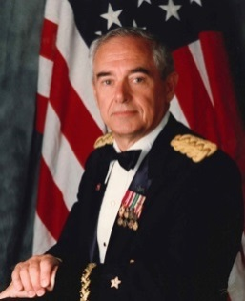
General Harber has served in this position from the start of the company. He initially served as an Infantry Officer at the LT level and was transferred by the Army to the Combat Engineer Branch in the Army Corp of Engineer in 1959. General Harber is a Master Army Aviator with more than 10,000 hours in military and civilian fixed and rotary wing aircraft. He served as the NATO Northern Regional Wartime Construction Manager (RWCM) and Commander of the 194th Engineer Brigade (Theatre Army) from 1989 through 1995 responsible for the United Kingdom, Norway, Denmark and Jutland. Command included five (5) Army Engineer Groups (up to 5000 Soldiers per Group). In the Northern Region Command included USAF Red Horse and Black Horse Engineers, USN Sea Bee’s, and a blocking force TF USMC MEF when required in the very northern part of the region. General Harber worked closely with the UK Commanders-In-Chief Committees on mission wartime support requirements.
General served at the Pentagon on numerous occasions to include the Chief, Construction Branch, Army Instillations Division and served on the Chief of Engineers General Officer Executive Council that advised the Chief of Engineers on matters relative to Engineer Unit Requirements and Wartime missions of Engineer units. This Council was made up of all General Officer Commanders and advised the Chief of Engineers on matters relative to Engineer Unit Requirements and Wartime missions of Engineer units. Council was very involved in Desert Shield/Desert Storm for the employment of engineers.

Nation Building: Central America-Panama, Honduras, Costa Rica and El Salvador -1992-1995
General Harber Commanded the Nation Building Efforts in Central America with primary focus on Panama, Honduras and Costa Rica building roads through the jungle and construction of schools, clinics and support facilities. Those efforts were supported by a Flight Detachment of CH-47s from Fort Rucker, AL and USAF where needed for supply missions. General worked closely with the State Department and the Ambassadors in those countries to provide the critical infrastructure requirements approved by the United States Government. The El Salvador mission was in the early stages from conflicts that were happening in that country and the Command Staff Representative spent a considerable amount of time in assisting in the stability and defining future support should the United States approve that action.

General Harber completed 42 years of service and retired as a General Officer of the Line in 1997.
Broadband Technology Corp (BTC) provides energy alternatives, information technology, equipment, software and services. General Harber became interested in the renewable energy in 1972-1975 when he was stationed at the Pentagon and served as the Chief, Construction Branch in the Army Installations Division. At that time the Army was very involved in alternate energy such as geothermal, solar and other sources of energy as outlined in the ECIP (Energy Conservation Investment Program). General Harber was a Major at that time and was instrumental in progressing that program in the Army Installations Division and initiated, reviewed, designed approvals at various military installations and construction. He was awarded the Army Commendation Medal (ARCOM) for this work.
BTC can provide personnel a method of training and support that can be expanded to provide information and education to not only the civilian and governmental employees but to the military service members and the families where applicable. The BTC electronic delivery system can further be expanded to include special employee training and Military Occupation Skills Qualification (MOSQ). BTC can provide training whether the employee or student is located in The United States (CONUS) or if they are located outside the United States (OCONUS). The electronic delivery system developed by BTC can be utilized to provide education and provide critical information that is needed by support services and Support Groups to help the client, agency, government and personnel member’s in their daily routine requirements for support and critical needs.
Integrated Team Concept
BTC and its partners offer the following services:
- Biomass Electric Power Generation
- Medical Waste and Hazardous Material Disposal and WTE
- Geographic Information Systems (GIS) and property boundary overlays
- Vulnerability Assessment
- Environmental Support
- Engineering Support and Services
- OSHA Support and Services
- Base Realignment and Consolidation Support (BRAC)
- HAZMAT and Environment Evaluation and Planning
- Media Development in varied formats including CD/DVD, HDTV Formats
- Content Development
- Training Delivery
- Training Management and Delivery System(eTMS)
- Information Technology Equipment
- Software Development and Management
- Computer Systems Integration Design Consulting Services
- Internet Service Provider (ISP)
- Gigabit Ethernet network connection
- Portal and Enterprise Portals
- WEB Development
- Web Based Course Development and Delivery
- Voice over IP
- Wireless Connectivity and Web Telemetry
- Remote Asset Management products for construction equipment, Farm Type Equipment, tractors and irrigation pumps, Solar and Wind Farm Equipment, passenger vehicles and buses, Water Craft and Aircraft
- Long distance audio and visual communications
- Requirement Assessments
- Personnel Phone Home messages via computer from any telephone
- Alert Notification, Staff Recall System
- Inoperable Web Information Alert System (IWIAS)
- Ayantra satellite and wireless tracking system for vehicles and equipment
- Additional Complimentary Services
- Medical Inventory Management System
- Hospital at Home
- Robotics Support and Capabilities
- Home Health Care

INTRODUCTION:
BTC is very interested in supporting the energy requirements of the DoD Military and will participate in the bidding of the Dyess AFB WTE Project and any other of the USAF energy requirements related to this Sources Sought. BTC with our Teaming Partners CRATECH, Grimes Engineering and PRM Energy (the largest manufactures of gasifiers in the United States) are our Teaming Partners and single largest subcontractors. After extensive research of capabilities and experience a logical decision to Team with these two companies, each with highly specific and applicable expertise, to initially focus on the largest single energy market on the plant, the Department of Defense (DoD). With the emerging alternative energy market beginning to be a major area of interest for the DoD it not only made sense for teaming capabilities to meet the business potential but also for national defense purposes as well as Federal, State and Local Governments requirements. The latter reason being the contributions our companies can make toward helping the United States achieve energy independence..

Broadband Technology Corporation (BTC)
BTC was founded by Brigadier General (Retired) Gary G. Harber and son LTC (Retired) are retired Army Officers who have extensive backgrounds in Army acquisition, R&D, logistics and international sales. The mission of BTC is to assist the military and other Governmental agencies find tangibles means to reduce energy consumption by providing the necessary military know-how to bring alternative and renewable energy companies into the DoD energy market.

CRATECH, Inc.

CRATECH was founded by Mr. Joe Craig in 1990 for the purpose of developing a new generation of small scale (< 20 MWe per unit) power plants. The plants are expected to increase the efficiency and lower the cost of generating power from fuels such as wastewood and MSW. The design and process has become fully developed and the results are patents intellectual property related to gasification processes for conversion of several types of solid wastes to energy and useful by-products.
Using its proprietary technology, BTC and CRATECH are pursuing waste gasification projects in the US and O’CONUS projects to design an integrated waste management system, to include gasification waste to energy, in several other countries.

Purpose and References
This SOURCES SOUGHT is provided to the Department of the Air Force, Office: Air Combat Command in response to the referenced solicitation to be executed under the provisions of a Power Purchase Agreement (PPA) for the generation of electric power to be delivered to USAF Facilities as directed by the Department of the Air Force using renewable energy fuels derived from Municipal Solid Waste (MSW) and Woodwaste.
"To procure reliable locally generated renewable and alternative energy (RAE) utilizing Power Purchase Agreements (PPA) or other contractual equivalents. It is our understanding that the intent of the USAF is only to purchase the energy that is produced and not to acquire any generation assets. The Contractor shall develop, finance, design, build, operate, own and maintain the energy plant"

SOURCES SOUGHT Overview

It is understood by BTC that this is information Sources Sought Synopsis and market survey for information only, and is to be used for preliminary planning purposes. The purpose of the response to this sources sought is to provide information of the capabilities of Broadband Technology Corporation (BTC) with its teaming partner CRATECH of providing the very best support to the USAF to obtain the DoD directed NetZero requirement to assist the United States Air Force in meeting the goals set forth by DoD and enhancing the capabilities of the USAF in providing the very best value to the Unites States of America and our force structure. General Harber fully understands the complexity of this endeavor and has served in the position of the Construction Branch Chief in support of the United States Army and the facilities supported in the Installations Division. General Harber was instrumental in the rewrite of TM 5-803-4 to support the requirements of the USAF and USA Aviation Facilities and criteria.
The BTC desires to assist the 7th Contracting Squadron has been tasked to request information for a project concerning a Waste-To-Energy Electric Power Generating Facility (WTE) at Dyess Air Force Base, Taylor County, Texas. The information to support the proposed project will be a Utility (Power Purchase Agreement) Firm Fixed Price contract.
THE BTC TEAM CAPABILITY AND EXPERIENCE:
The BTC TEAM has developed the capability to support the goals of the DoD NetZero requirement the be able through patented process that will deliver the very best and economical system to provide electrical energy at a very competitive cost and at the same time to reduce the continuing problem associate with the waste that is collected from operations of facilities and the continuing problem of landfill operations.
The BTC Team sorts and treats materials that are not suitable for gasification, including batteries, mercury switches, electronic components, concrete and rock waste, etc., are also removed during the sorting process. Depending on the average calorific value of the combined waste streams to be converted to energy, additional high BTU feed may be required for best gasifier efficiency. Such high BTU feeds could include waste tires, waste oil, and creosote treated wood all which are available, in the amounts required, within the greater USAF Installation area.
The BTC Team response in support of the SOURCES SOUGHT for power generating facility includes sufficient gasifier capacity to handle all municipal solid waste, lightweight construction and demolition waste, as well as bio-sludge generated on the USAF installation. In addition, we will arrange for the use of other solid waste generated in the local area for additional fuel. We have already conducted the necessary negotiations for these additional waste streams and are prepared to initiate contracts with the waste haulers once an approved Power Purchase Agreement is issued by the USAF.

Technical Overview

Air fed gasification is a proven technology. It is also inherently cleaner and more efficient than combustion or incineration. Cratech has developed an air fed gasification process that is closely coupled to a gas turbine engine. The heart of the gasification process is a pressurized fluidized bed reactor. This reactor produces a syngas laden with ash that is directed into a hot gas cleanup unit. This cleanup unit completely removes the ash and follows by directing the clean hot syngas to the combustion chamber of the gas turbine engine. This is an advanced power process over the combustion/gasifier boiler plant most widely used in the industry today. The Cratech process has a smaller footprint is more efficient and can be economically applied in sizes as small as 1 MWe. The process does not consume water and produces a dry powdery ash similar to flyash.

The BTC Team proposed plant consist of 4 gasifier/turbine units and one organic rankine cycle unit for an efficient combined cycle plant with a net power output of about 9 MWe. A process flow diagram for this system, as proposed in this document, is shown in Figure 1. The major components shown include the tipping floor, sorting table, preprocessing, final size reduction, fuel storage hoppers, bucket elevators, gasification reactors, hot gas cleanup, gas turbine combined cycle unit, transformer and switchyard.

Since the BTC Team modules are scalable, the plan for the USAF can be tailored to the requirement of the installation and can range is to begin the project with a 9 MWe net (at the buss bar: power delivered to the grid). The BTC Team plant can expand in increments to accommodate the installation requirement for the plant capacity depending on the amount of waste material available to the plant not only at the base but surrounding area.

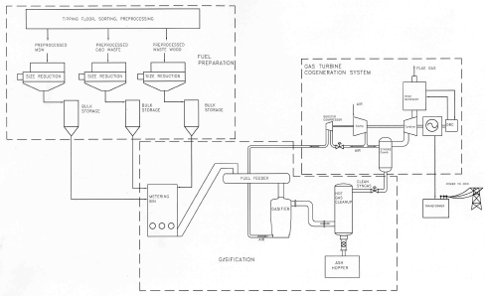

Figure 1: Process Flow Diagram for a 9 MWe Gasification/gas turbine Electrical Power Plant

BTC Team Experience

BTC Team is an alternative energy and services Teaming Agreement Partners with affiliated companies specializing in engineering, solid and hazardous waste management and wastewater treatment project design and construction, electronic design automation, landfill design and construction, alternative energy electric power generation as well as US Government contracting, research and development and acquisition.

While BTC was initially organized in 1998 and then incorporated in May of 2001 to pursue Department of Defense (DoD) support for technology requirements to include alternative energy projects. BTC Team Member Companies and Teaming Partners have been in the engineering, solid waste to energy equipment manufacturing, construction, and waste management business as well as in defense support services businesses for decades.

The senior professionals of BTC have extensive experience in the areas of alternative energy technology, DoD acquisition, R&D and program management. This experience also includes military management experience at senior command levels. In terms of environmental engineering, BTC senior executives have years of experience in designing and executing structural hydrogeology as well as wastewater, solid, hazardous, and radioactive waste management engineering projects.

The BTC professional staff members have advanced degrees from some of the world’s most prestigious engineering and military schools and projects both in the US and overseas. Moreover, a key teaming partner member has been designing and manufacturing gasifier equipment for over 30 years and is the largest manufacturer of gasifiers in the United States.

In essence, the team assembled by BTC, for the USAF project possesses some of the best talent in the fields of waste to energy and electricity generation. This talent pool was then linked with former Army officers who possess in-depth experience in defense program management, acquisition, contracting and R&D. The resulting Joint Venture is uniquely equipped to design, construct and operate alternative energy Waste to Energy (WTE) plants using patented and proven technologies that will assist the Department of the United States Air Force and the Department of Defense to achieve a major portion of their alternative energy objectives, as well as DoD NET "ZERO" goals for energy utilization and reducing waste going to landfills. Equally as important is that this assembled BTC team can achieve these goals in the immediate present as opposed to 10, 15 or even 30 years in the future.

Scope and Term
The overall BTC Team support scope of this proposed public private partnership project includes the design, permitting, engineering, financing, construction, commissioning and operation of a 9 MWe (at the buss bar) Waste to Energy electrical power generating facility and associated municipal solid waste (MSW refuse sorting facility for refuse derived fuel (RDF) preparation under a contract pursuant to FAR Part 41.
These facilities outlined in the Sources Sought can be represented as the first phase in developing a clean and green waste to energy facility/facilities that will be capable to serve the Military Installation and can be expanded to support the grid or areas near the facility. The potential is for a total of 80 to 150 MWe of power generation for this area. The term of this agreement is, ideally, for a 30 year Power Purchase Agreement which provides to both parties BTC and the USAF the best economies of scale and will be designed IAW the facility requirement that will be fueled from municipal solid waste and/or biomass that meet the requirements of the Energy Policy Act of 2005, section 203 (b) (1).

Benefits of the btc team approach to energy

Benefits of the proposed renewable energy project to the DoD, the United States Air Force as well as the surrounding areas of the military installation include:
- No capital investment by the USAF or the Federal Government. All costs and risks associated with the project for design, permitting, engineering, and construction will be assumed by the BTC Team and its' investors;
- Green onsite (extremely low air emissions) conversion of renewable fuels, that include municipal solid waste, light construction and demolition waste, bio-solids, and other organic waste, to electricity using proven and clean gasification technology;

- Reduction in solid waste going to landfills, making the USAF Base area a NET ZERO installation for waste by the close of 2017; assuming contract approval not later than 31 DEC 2014;

- Scalable technology with capability to meet a significant proportion of current USAF Installation base electric power requirements, as well as a significant portion or all of base power needs well into the future;

- Highly redundant and reliable power plant designs that can operate on multiple fuels to provide reliable and secure power generation capability even in “worst case” scenarios;

- Competitive and guaranteed long-term power rates, which will become substantially less expensive than outside commercial sources of energy during the term of the agreement;

- Reduction of regulated and greenhouse gas emissions as compared to commercial production of energy from coal, and landfill alternatives for solid waste disposal such as incineration and,

- Full compliance with Executive Order 12759 (efficiency goals for federal installations) and Executive Order 13514, which sets clean energy goals for “green house” gases and bio-degradable waste reduction.

- For the USAF this project is estimated that it will represent an approximate $35 to $50 million dollar initial investment for the Phase I 9MW system with the additional benefit of creating approximately 40 new permanent jobs. Later phased project expansions, should USAF decide to exercise these options, will create additional jobs and revenues for the surrounding community.

Plant Location

It is anticipated that phase 1 facility will be located on FEDERAL Leased / LICENSED or appropriate authorized document for the use of the government land LOCATED AT THE INSTALLATION AND in AN AREA THAT WILL PROVIDE ACCESS TO THE PROPOSED PLANT THAT WILL NOT VIOLATE the SECURITY OF THE MILITARY INSTALLATION.
It is understood that the USAF will provide real estate that is located on sufficient acres of land to allow BTC to be near or adjacent to the landfill but inside the installation boundaries area on which the power house and switchyard will be constructed in order to comply with the requirement that renewable power be generated on US Government land. As such the facility layout, in total, is comprised of land both adjacent to and within the USAF installation. This layout allows BTC to construct the plant so it complies with US Government direction while at the same time affords waste delivery trucks access to the plant in order to deliver the necessary Municipal Solid Waste (MSW) the plant requires for Refuse Derived Fuel (RFD) without the need to enter the USAF property. If necessary a manned security gate/station can be provided by the contractor or IAW Security Regulations of the USAF.

It is anticipated that the 5 to 20 acre plot of land required to build the power house and switchyard will be leased or licensed to BTC at no cost or low cost lease for the duration of the 30 year contract. Moreover, because this plant will be located on leased or licensed land that adjoins the existing landfill and that has been permitted for solid waste and power generation, permitting by the government, should be perfunctory.

The location of the landfill on USAF property that is also near the access road to the landfill will facilitates truck traffic carrying municipal solid waste (MSW) to the gasification plant. Highway or road provides for access to and from the plant without the need for solid waste haulers to enter military reservation proper. This avoids any possible breach of security that could arise if these trucks were required to enter the base or institution to gain access to the plant.

Plant Financing and Cost

BTC investors have pre-qualified this project for private investment, with final financing approval contingent upon receipt by BTC of an approved power purchase agreement (PPA) that contains a blended rate of not more than $0.08 per kWh with a not to exceed 3% annual cost adjustment for inflation. This means that all of the capital required to design, engineer, permit, construct and commission this plant will come from non-governmental sources. Upon receipt of the US Government PPA BTC will immediately form a special purpose vehicle (SPV) company to finance, design, permit, build and operate the facility for the duration of the concession period, which is anticipated to be 25 to30 years. The initial estimated cost for Phase I installation, comprising a 9 MW to the grid gasification plant with associated sorting facility, power interconnect is estimated to be approximately $35 to $50 Million.

Technical Overview
Phase I facilities and equipment will be located at the site described above within the confines of the USAF Energy facility boundaries. This facility will include the MSW gasification system coupled to the gas turbine gensets, maintenance facility, control room, MSW sorting and fuel prep area, offices to include staff amenities, conference room, security fence and gate, scale house and scales, 69 kV power connect line, and all service roads and utilities.

These systems are highly reliable and inherently much cleaner and more efficient than MSW incinerators, especially when incinerators are operated in a mass burn mode. With recent advances in design, including the use of advanced flue gas clean-up process trains and proprietary flue gas recycle for heat recovery and reduction of NOx, these gasification systems qualify as green technologies for solid waste conversion. The proposed solid waste to energy conversion systems for USAF will utilize The Cratech patented power process what couples a pressurized fluidized bed gasification process with a gas turbine combined cycle unit.

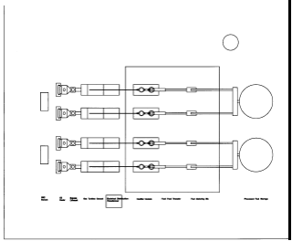
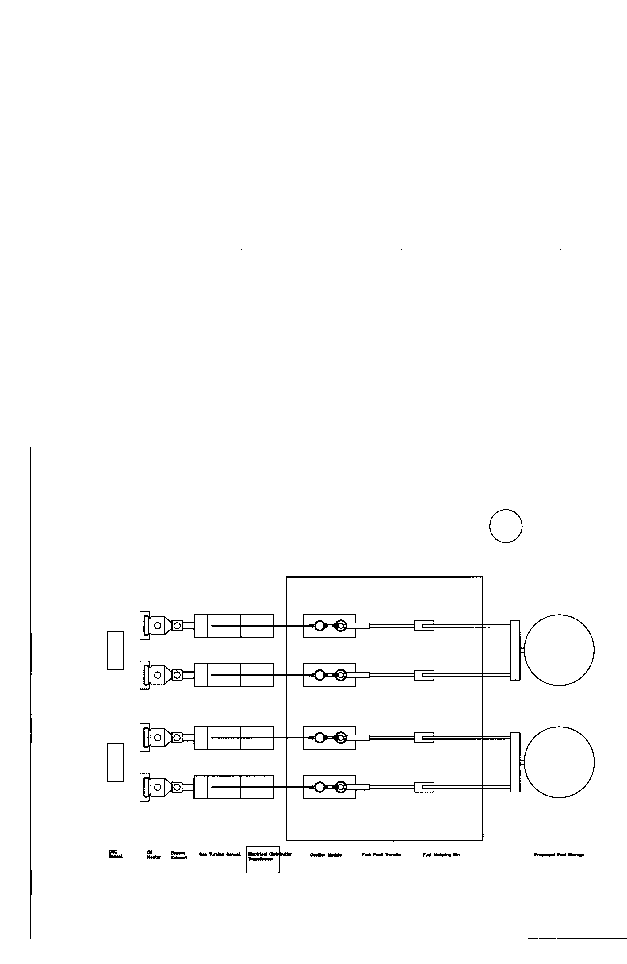
Figure 2. Typical Layout of a 9 MW Gasification Plant With Provision for Expansion, Showing Gasifier Line, Powerhouse, Water Treatment Plant, Offices, Tipping and Sorting Floor, Gatehouse, Scales and Maintenance Shop
These systems are normally deployed in 9 MWe (at the buss bar) modules with each module capable of processing approximately 250 to 350 tons of raw MSW per day. A line drawing of a 9 MWe gasification plant, including the tipping floor and sorting line, of the type BTC proposes for Bastrop is shown in Figure 2 above.

The presence in the waste streams of materials not suitable for gasification, including batteries, mercury switches, electronics, will be sorted out and either recycled or properly disposed of IAW environmental regulations and policies. To ensure there is sufficient supply of Municipal solid Waste (MSW) available the facility will require the intake and sorting of approximately 250 to 350 Tons Per Day (TPD) of MSW, of which some 200-220 TPD, depending on calorific value and moisture content, will be fed to the gasifier. The balance of the raw material, including ferrous metals, aluminum and glass, is normally removed on site during sorting with components, such as concrete and rock waste, etc. are also removed during the on-site sorting process.

Importantly, the proposed USAF power generating facility includes sufficient gasifier capacity to handle all municipal solid waste, lightweight construction and demolition waste, as well as bio-sludge generated by the adjacent municipal areas since the USAF Base may produces much less waste per day than the gasifier will consume (200-220 tons per day. This concept also benefits the communities near the USAF Facilities in control of their waste steam.

ENVIRONMENTAL IMPACT

Operation of the waste to Energy Facility will allow the USAD to reduce the amount of waste it sends to landfill by more than 90%. As described below, gasification generates less greenhouse gas (GHG) equivalent per kWh of energy generated than does a landfill and certainly far less, in terms of magnitudes of reduction, when compared to coal fired power plants.

Government sponsored studies in the US, Canada, and elsewhere have shown that air fed gasification is the cleanest technology available for WTE conversion, with a lower carbon release per kWh of electricity generated than incineration. Waste to energy, in general, has been shown to emit fewer pollutants per MWh of energy generated than landfill gas and coal fired power plants. In fact, as shown in Figure 3, a properly designed and operated waste to energy facilities emits less greenhouse equivalents per kWh generated than do landfills, even when such landfills have gas collection systems.

In the case of the Cratech power system, the fluidized bed gasifier and gas turbine combined cycle unit, along with the pre-sorting of the refuse derived fuel (RDF) components, allow the waste to energy power plant to operate with air emissions that allow it to be permitted as a minor source under the provisions of Title V of the Clean Air Act.

The initial USAF Base or Installation gasification facility will produce 9 MWe (at the buss bar) of clean, green, renewable energy from approximately 200 tons/day of light weight construction and demolition (C&D) waste, 60 tons/day of commercial source separated waste, and 10 tons/day of used tire chips. The facility will have the lowest emissions of any facility in the world for conversion of this kind of solid waste, and will have no adverse impacts to human health or the environment.

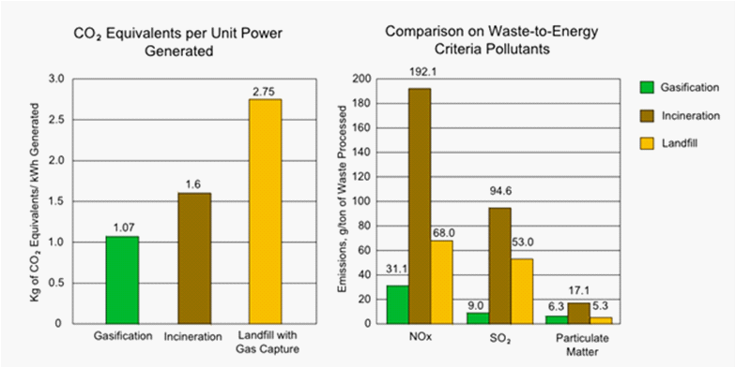

Figure3.Comparison of (left) carbon dioxide equivalents and (right) NOx, SOx and particulate emission.per kWh generated by landfill gas capture, incineration and gasification waste to energy conversion plants.

The primary environmental advantages of the facility may be summarized as follows:

- World’s Cleanest Technology. The BTC Waste Management/Cratech Gasification system has the lowest emissions per ton of waste of any waste to energy technology in the world. In fact, the emissions are lower than incineration, landfills with gas collection and treatment systems, compost facilities, and coal fired power plants;

- Gasification, Not Incineration. The BTC/Cratech Facility is a gasification facility, with regulated emission that are far lower than those of MSW incinerators with emission concentrations that are between ten and 1,000 times lower than national ambient air quality standards (NAAQS). The facility does not burn waste, but instead heats the waste to form a synthesis gas, which is then converted to clean, green, renewable energy. The USEPA, Department of Energy, Los Angeles County, Alameda County, and several other groups have determined that the technology used by the BTC/Cratech system to gasify the waste is the cleanest technology in the World;

- Recycling the Waste. The waste that is transported to the Gasification Facility will initially be sorted at the Sorting Building before transport to the Facility for processing. The waste will then be again sorted at the gasification and sorting facility, assuring that potentially recyclable waste is recycled, and that the balance of the waste is reused as fuel to create energy;

- Proven Technology. The Gasification Technology that will be used in the USAF Gasification Facility is proven technology that has had similar components systems in operation for years.

Inclusive in the first phase of this project will be the installation of a feeder line connecting the BTC electric generating plant to the grid. The feeder line will operate at 69kV, or at a voltage as required by the USAF and the local electrical utility. It is assumed that connectivity to the grid will be made at the closest substation to the generating plant, which the distance is to be determined after the completed study is completed and approved. Cost of this feeder line and connectivity services will be part of the overall project cost.

Scalability
The gasification facility will be readily scalable to provide additional generating capacity in 12 MW (Nameplate) modules at the direction of the USAF and the customer served.
Toward that end, the initial plant will be designed with Pre-planned Product Improvement (P3I) hooks to facilitate these upgrades. Given the modular design of the gasifier lines coupled with the scalability or “Plug and Play” design of the plant control and intertie, infrastructure upgrades to the facility are more easily facilitated and at less cost when compared to conventional discrete power plant designs.
Moreover, should the Government eventually decide to expand the power production capability of the plant by also incorporating gas turbine / gasification hybrid combined cycle system, the steam from the HRSG units will then be used to help drive steam turbine generators in the power house, while the gas turbine(s) are directly coupled through a gear box to electrical generators. This combined cycle generating capacity can be added using either natural gas or shale gas should this gas become available at a competitive rate and the Government decides to expand the plant for peaking purposes.
The potential incorporation of gas turbines is mentioned purely to provide the Government with an option that will be capable of generating demand power at stable cost rates that will be less than current rates. BTC’s ability to offer this option is afforded solely because of proprietary plant design factors and implementing software. This fact is mention here in order to emphasize the flexibility of the BTC biomass power plant solution to readily accept upgrades in capability beyond Waste to Energy technical solutions should the Government desire to exercise that option.

Financials

Private Investment

The funding necessary to bring this plant into fruition will be supplied, in total, by private investment. These funds will be utilized to design, engineer, permit, construct and commission the plant and will be providing upon receipt of a Power Purchase Authorization (PPA) from the US Government to BTC. Additionally, no government loans or government loan guarantees will be required. The only requirement to trigger the availability of this private capital, necessary for project execution, is the aforementioned PPA issued by the US Government to BTC.

Once BTC receives the PPA we will form a special purpose vehicle (SPV) company to finance, design, permit, build and operate Phase I of facility for the duration of the concession period, which is anticipated to be 25 to 30 years. The estimated cost for the Phase I installation, which is comprised of a 9 MW (delivered to the grid) gasification plant with associated sorting facility, power interconnects, is approximately $35 to $50 million dollars.

The Phase I facility will remain the property of BTC in accordance with the policy established by the DoD in the release of their July 2012 Renewable Alternative Energy (REA) solicitation. In this solicitation the Government establishes the policy to contract for electric power, derived from privately capitalized alternative energy power plants, under Power Purchase Agreements (PPAs) that have duration of up to thirty (30) years. This government policy also stipulates that that ownership of such alternative energy plants remain with the contracted provider and be operated as a Contractor Owned Contractor Operated(COCO) facility. BTC is fully supportive of these policies and is prepared to execute this project in full compliance with these US Government requirements.

Cost to the Government

The new gasification facility will be capable of providing base load power at an initial rate of $0.08 per kWh. This rate can be guaranteed (subject to the terms of the waste supply agreement) to have no more than a 3% annual escalation rate or a comparable blended escalation rate percentage, whichever is lower, for the duration of the anticipated 30 year concession period. During the concession period BTC will operate the plant as a Contractor Owned Contractor Operated (COCO) facility. Our ability to maintain this relatively low cost per kWh of $0.08 is based on the assumption that there is little or no cost associated with the use of the land upon which the plant will be constructed, and that the gasifier continues to be fired by RDF for which the facility is paid a tipping fee. With current MSW tipping fees in several metropolitan area ranging from a low of $12.00 per ton to a high of approximately $22.00 per ton, BTC is uniquely able to offer the USAF and surrounding communities this competitive and stable $0.08 per kWh rate for electrical power while still satisfying investor use of capital returns.

Plant Operations
Plant operation will be a on a 24/7 basis with scheduled annual maintenance requiring approximately 7-10 days of off line time per year. A total of approximately 40 professional, skilled and semi-skilled workers will operate the facility in three shifts. A staff of approximately 20 will be required for the day shift. Swing shift will require approximately 13 workers and the night shift will be staffed by 5 or 6 workers. The structure of this work force is as depicted in the chart at Figure 4 below.

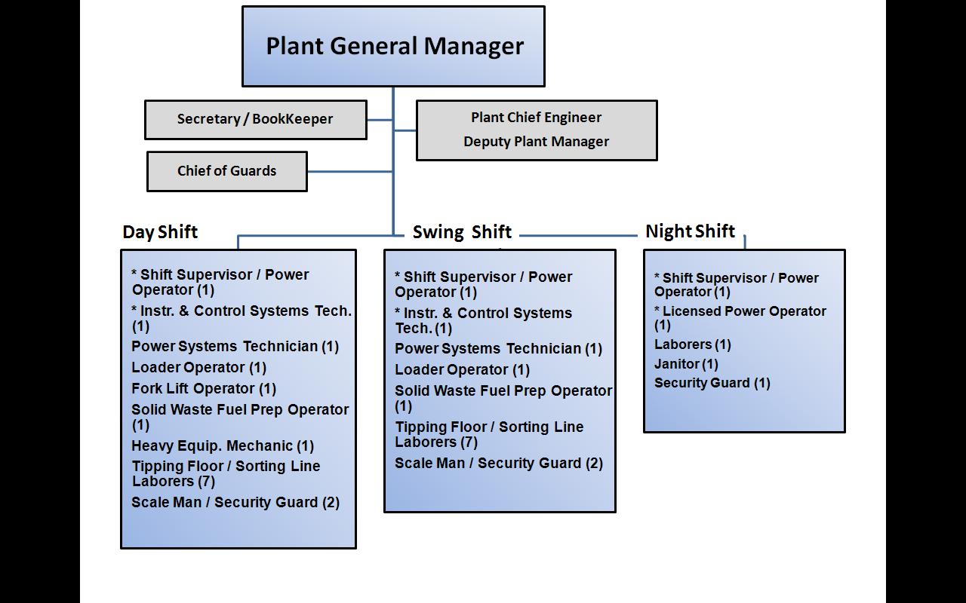
Figure 4. Facility organization and staff(* Indicates Licensed/Certified Power/Boiler Operator )

The final determination of manning, and the operational structure to support 24/7 plant operations will be made by the USAF COR/COT BTC plant management personnel at the award conference to be held not later than 30 days after receipt of the Government PPA.

Power Delivery

Power delivery from this facility will be provided on a 24/7 basis with the initial power delivered to the USAF being "behind the meter"; that is, the USAF Base/Facilities will be considered, by the local utility as an independent generator of electrical power for its sole use.

Since the Phase I Gasification facility will not provide all of the base load power required by the USAF, it will be necessary for the USAF Base/Installation to remain connected to the local utility for a portion of its base load power requirements as well as for demand load and back-up power during the Gasification Facility maintenance periods. Details of this arrangement with the local utility will be the subject of an operating agreement to be finalized during the post award conference mentioned in paragraphs above.
Energy Security

The waste to energy gasification facility, described in this proposal, will increase energy security at USAF Bases and Installation by providing an alternative local source of electrical power from a renewable fuel. In an emergency, or as a matter of DoD Net Zero and environmental policy, the base and community landfill can serve as a source of RDF for the gasifier and represents a fuel supply sufficient for several years of operation just from mining the existing landfill. In terms of energy security, this aspect of having the plant located on the adjacent landfill affords USAF stock of readily available and usable fuel for local electricity generation if ever required in a emergency, such as the disaster that impacted New Orleans during Hurricane Katrina.

8.3 Physical Security
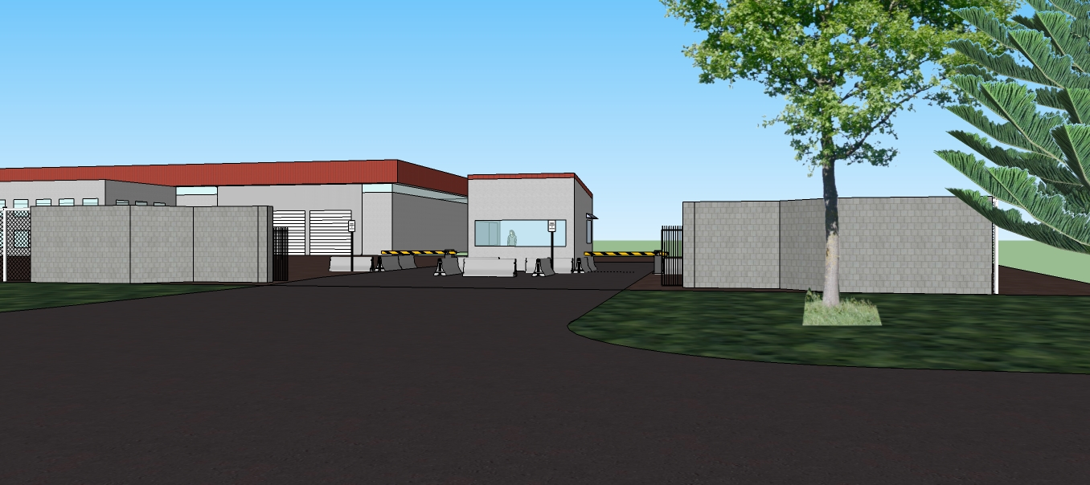
Plant physical security will be maintained by a 24-hour guard service operating under the overall control of the Plant General Manager. Daily supervision of the guard force will be the responsibility of a dedicated Guard Chief. In addition to the guard force the plant will also be enclosed with a chain link fence with only one truck entrance for positive access control purposes. Renderings of the facility are shown in Figures 5 and 6 below.
Figure 5 - Rendering of Facility Entrance Showing Scale House / Guard House and Sorting Facility

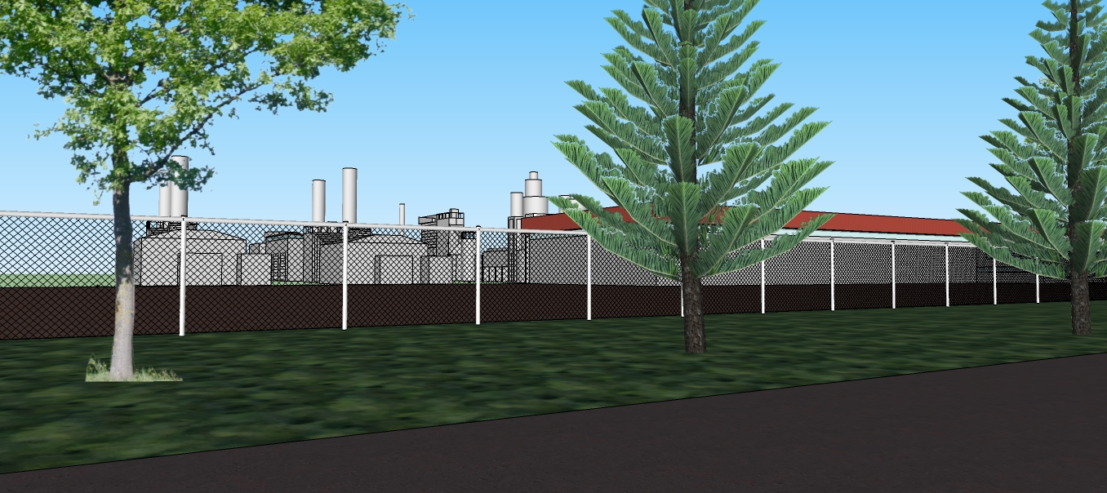

Figure 6- Rendering of the Facility From the Approaching Service Road .

Facility Quality Assurance
Day to day plant Quality Assurance (QA) will be the direct responsibility of the plant manager and deputy plant manager who will interface with whomever the servicing utility designates for plant QA oversight. Periodic unannounced QA audits will be conducted semi-annually by an outside audit agency approved by the COR/COTR, with the cost of these audits included in the BTC plant operations costs. The type, duration, composition and selection of the auditing agency will be finalized during the post award conference.

Plant Ownership and Liabilities
The facility will be financed, designed, constructed, owned and operated by an operating company formed by BTC and the investor as a Special Purpose Vehicle (SPV) entity. At the conclusion of the initial public private partnership (30-year PPA period) the electrical generating plant will remain the property of BTC and its equity investors. During the entire 30 year operating period BTC will maintain a performance bond as a means to indemnify any liabilities and or power disruptions associated with damages and/or long term non-performance issues arising from labor issues, equipment failures, legal disputes and/or force majeure events.

Legal and Permitting

Overall system design, engineering, permitting and construction, as well as detailed design of the gasification systems will be the responsibility of our design team headed up by Grimes Engineering a teaming partner in the BTC Project Team. Grimes and Associates, Consulting Engineers, L.P. is a full service professional architecture/engineering/construction management/environmental firm. Our BTC Team has extensive background and experience in all aspects of the required engineering and environmental support requirement to include energy conservation, waste disposal and waste to energy projects involving solid waste and landfill gas, including projects where hazardous waste landfills, sorting facilities, compost plants, transfer stations, leachate treatment facilities, landfill gas to energy facilities, and medical and hazardous waste treatment facilities were designed and constructed.

Moreover, as mention earlier in this proposal, the PRM gasifier solution is an excellent choice because of its proven high Reliability, Availability and Maintainability (RAM) with some units in continuous operation for more than 30 years, with no more than routine maintenance performed.

Use of USAF and Community Landfill Site for Permitting Purposes

The cooperation of the USAF and community Landfills and the fact they are already permitted as a landfill not only simplifies the permitting process, but also expedites the process. The permitting process simplification and expediting is achieved because the BTC Waste to Energy facility can be permitted as a modification to the existing landfills which will also serve to expedite plant construction.

Requirements for Private Financing
In order for the facility to qualify for private financing the following agreements must be in place:
Waste Supply Agreement: This agreement must be with a licensed and bonded waste supplier and must have a minimum term of 20 years, provide a minimum tipping fee to the facility of approximately $20.00 per ton of raw waste received with a three year average of 3% per annum tipping fee escalation. A survey of waste haulers in the USAF Base and Community Areas for achieving these figures will be conducted to determine an actual cost and distance of haul to support the plant requirement.

Power Purchase Agreements: These Agreements must be in place prior to the initiation of the private investment final due diligence process. The PPA must provide for a rate of not less than $80 per MWh for delivered power averaged to a minimum of 216 MWh/day.Along with this agreement, approval of an application for renewable energy tax credit of $10/MWh for all power delivered will also be required. Details concerning these rates will be a topic for discussion at the post award conference with the USAF and Utility Manager and/or COR/COTR.

Thirty Year Low Cost / No Cost Lease: The lease will be required for at license/least 20 acres of land if the landfill is on base or with the community landfill and access to adequate haul road that is available to access the plant/landfill land adjacent to the 20 acre site parcel. These land parcels will be the area upon which the Phase I facility will be built and upon and which expansion of the facility can be carried out; should the Government desire to expand plant beyond Phase I of operations.

"Full Wrap" Engineering, Procurement and Construction Contractor: BTC and CRATECH staff have worked with EPC contractors and will select the most a suitable EPC company for the project, once the project is awarded.

Project Management

BTC (ITCR) Project Managers are formally trained in project management including in the use of Microsoft Project© or similar type software to help visualize and control projects undertaken by the company. The use of Project Management Software as means not only to track schedule to performance but also to track cost provides a very useful tool for project control, reporting and identification of problems for early-on project workarounds if required. We will continue this policy with the USAF WTE facility, starting with a Milestone 0, project kick-off meeting with the BTC Project Manager, EPC subcontractor representative and the CO or COR/COTR occurring not later than 30 days after receipt of an approved PPA by BTC.

At this meeting the BTC Project Manager will present a top level Project Management Chart for comment, revision and/or approval by the Government to establish a mutually agreeable path ahead. From this top level Project Management Chart (similar to the one shown at Table 2, below, detailed Project Management Sub-Tasks will be developed to govern the accomplishment of every phase of the project from permitting, through design, construction and facility commissioning.

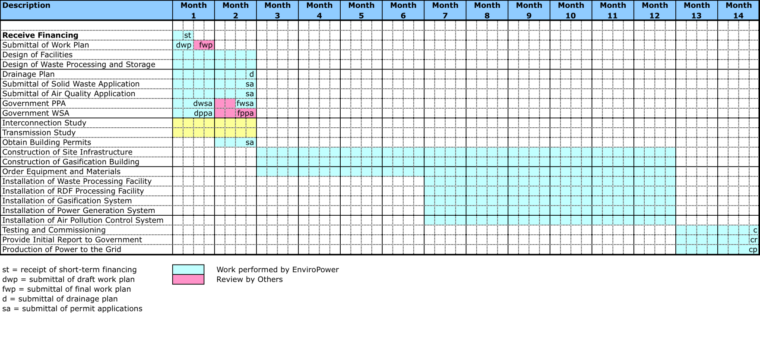
Table 1: Note a Chart Like the One Shown Above will be Used to Support Path Ahead Discussion at a Milestone 0 Kick-Off Meeting

MEDICAL WASTE TO ENERGY:

Broadband Technology Corporation with our Teaming Partner ITC Renewable, LLC / EnviroPower, LLC JV Partners we can offer to include in the Waste to Energy Plant the capability to dispose of Hazardous Medical waste that is IAW all EPA and OSHA guidelines as well as regulations that govern the handling and disposal of Hazardous Medical Waste. The following information is provided as to the capabilities and generation of electrical energy as well as the capability to locate such a facility at a separate location if desired.

- Medical Waste to Energy as follows key points that are added in addition to those previously outlined in the basic WTE Response:
- Medical Waste Disposal will be collected over a relative wide area to provide adequate volume to support the system design requirement.
- Our Team has designed the Medical waste incineration system that can treat the medical waste that can be co-fired with our SMW and can run 24/7 and not have to be shut down as in presently done with most systems. The system will produce approximately 8.5 mw and is a rotary keel.
- The Medical Waste Incinerator will cost $6 to $7 Million each for a 2 to 8 MW system up to approximately $10 Million each.
- BTC JV Team is now researching Sites that will produce 2.5 to 8.8 MW and areas that are underserved.
- Options for construction are as follows:
- The gasifier could go forward first as a demonstration project and that could be easily expanded for the WTE project if incremental construction is desired.
- The demonstration project would not have to be on the Federal Property but can be collocated at the landfill.

Broadband Technology Corporation (BTC) Mission and contractor Team

BTC is a Service Disabled Veteran Owned Small Business founded in 2001 as a Technology Services Corporation with focus in alternative energy specializing in gasification based thermal processing of solid waste. The senior professionals of BTC have extensive experience in the areas of environmental, geotechnical, structural, and civil engineering, solid, hazardous, and radioactive waste management, hydrology, and hydrogeology, as well as water and wastewater systems. Professional staff from BTC and have advanced degrees from some of the world’s most prestigious engineering, business and military schools, and are well-published, and well known in their areas of expertise.
.
Table 2 below lists the BTC corporate partners on the USAF project team, along with their key executives, key staff and the roles and responsibilities of each corporate member on the project.

Table 2. Project Team Corporate Members, Key Staff and Project Roles

Corporate Team Member | Executives/ Key Staff | Area of Responsibility / Task / Function
BTC | BG Gary Harber (Ret)  LTC Fred Moll (Ret) | Project Origination & Overall System Design, Project Management, Government Liaison, Facility Operations, Environmental Compliance
CRATECH | Mr. Joe Craig, PE | Plant Equipment, Manufacturing and Engineering Support
Grimes Engineering | Mr. Joe Grimes, PE&A | Overall engineering, architectural, environmental services support, project management and design. Joe served 12 years as a pilot in the USAF and completed his service as a Captain.
USAF and Community Waste | Mr. to be determined | Waste Services

BTC and its associated project teaming partners are leaders in the design of complete biomass and solid waste to energy (“waste bin to buss bar”) systems. BTC and its corporate team members excel at the design of gasification based waste to energy systems to include the all-important selection, acquisition; sorting and formulation of solid waste for use as refuse derived fuel (RDF). The BTC project team corporate members are discussed in further detail below.
The mission of BTC is to assist the military and other Governmental agencies to find tangibles means to reduce energy consumption by providing the necessary military know-how to bring alternative and renewable energy companies into the DoD energy market.

CRATECH, Inc

Cratech was founded in 1990 for the purpose of developing a new generation of small scale
(< 20 MWe per unit) power plants. These plants are expected to increase the efficiency and lower the cost of generating power from fuels such as wastewood and MSW.
The concept is to closely couple a pressurized fluidized bed gasification system with a gas turbine engine to form a compact and efficient power plant. Cratech has funded development through cost sharing with several private companies and with the US EPA, US DOE, US DoD, the state of Texas, the state of Vermont, The Tennessee Valley Authority and with assistance from Texas A&M University, Texas Tech University, and Arizona State University.

Cratech is developing a new generation of small scale (less than 20 MWe) biomass fueled power plants. These power plants are based on closely coupling a gas turbine (Brayton cycle) prime mover with a pressurized gasification process. These plants are expected to increase the efficiency and lower the cost of generating power from fuels such as RDF and wood waste. The plant emissions will be comparable to that of natural gas fueled gas turbine power plants and will consume no water. The ash byproduct is a dry powder similar to fly ash.

Grimes Engineering:
Grimes and Associates, Consulting Engineers, L.P. is a full service professional architecture, engineering, construction management and environmental firm providing technical services for building owners throughout the Midwestern and southwestern United States since 1982. We provide a full range of construction (new, renovation, technical) design services as well as comprehensive environmental services (ESAs, asbestos, lead, UST). Our personnel are trained in their respective disciplines from national leaders in the appropriate fields (Georgia Tech, ASTM, etc)
Grimes and Associates is serving the engineering needs of architects throughout Texas and Eastern New Mexico. And large institutional clients like the City of Lubbock, Lubbock ISD, Veterans Administration, General Services Administration, etc. as well as with our architectural and environmental clients’ needs in the asbestos-related fields.
Grimes Engineering, LP is heavily involved in energy-conservation design, investigation of lead-based-paint, real estate inspections, facility renovation projects and construction management staff of over 60 years of professional management experience. Grimes Engineering has the expertise to manage a project from the beginning conceptual design, provide master plans and demographics studies, through the bond program, planning and design phases, right on through the construction delivery and construction administration phase of the project. The same person that you start the project with is the same person you finish the project with all the professional services necessary to ensure that our customers receive the maximum benefit from each of their facilities.
Cadence-Infrastructure
Cadence, headquartered in San Jose, California, is a supplier of electronic design technologies and engineering services in the electronic design automation (EDA) industry. EDA software and hardware enables everything from the design of individual transistors to the development of software before any hardware is built. Cadence has join the BTC team to design and build the necessary software controls to provide for state-of-the-art computerized management of the facility with emphasis on control room operations, automated system monitoring and status reporting as a means to maximize facility efficiencies, reduce risk and ensure continuous operations.

Anticipated Management Structure of the USAF BASE OPERATING Company/Special Purpose Vehicle (SPV)

Upon receipt of the Government Power Purchase Agreement BTC will form a subordinate operating company specifically to design, construct, manage and operate the USAF Waste to Energy facility. This subordinate company, more commonly referred to as a Special Purpose Vehicle, will assume the day to day onsite operations of the USAF Phase I, 9 MW waste to energy gasification facility as part of the commissioning process. The permanent staff, depicted above in Figure 4, will be hired during the later phases of plant construction. During the design and construction phases of the project the SPV will require specific senior management skill sets and hands on participation. Therefore during these initial phases of project the SPV will be specifically tailored to ensure project success and will include the senior management team shown in Figure 5. below.

Figure 5: Senior Management Team

List principal supplies/services to be subcontracted

Shown in table 3 below are the contractors that will be supporting the Broadband Technology Corporation Team on any projects resulting from this solicitation.

The companies shown should not be considered a finalized list, but merely those we have identified early on in this process as teaming members or subcontractors. The services/materials they will provide are noted in column 3 of the table. As noted earlier the list shown is not meant to represent all of the subcontractors that will be employed on a given project. The number and type of subcontractors to be utilized on project will be determined by the scope and requirements of that project. For that reason the BTC team reserves the right to add or delete from this list for any non-team member subcontractors.

Company Category | Company Name | Type Service or Supply | Relationship
Small Non-Disadvantaged-Veteran Owned Small Business | Grimes Engineering | Engineering, Procurement and Construction (EPC) | Sub-Contractor
Veteran Owned Small Business | Grimes Construction | Engineering Procurement Contractor | Sub-Contractor
Veteran Owned Small Business | PRM- Energy | Gasifier Manufacture and Installation | Teaming Partner
Service Disabled Veteran Owned Small Business | Consolidated Energy Services Global (CESG) | Project Management | Joint Venture Partner
Small Disadvantaged
Woman Owned/Veteran Owned Small | Blazin, Inc. | Contract Administration | Sub-Contractor
American Indian Tribal Owned Small Business | AQuate Corporation  SBA 8a Certified | Support Services | Sub-Contractor
Table 3 Teaming Partners and Subcontractors Initially Identified as Potential Participants in Biomass Projects

Brief Resumes of Key Personnel

BRIGADIER GENERAL GARY GREEN HARBER, UNITED STATES ARMY RETIRED
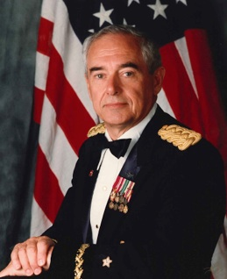
General Harber served as an Infantry Officer at the LT level and was transferred by the Army to the Combat Engineer Branch in the Army Corp of Engineer in 1959. General Harber is a Master Army Aviator with more than 10,000 hours in military and civilian fixed and rotary wing aircraft. He served as the NATO Northern Regional Wartime Construction Manager (RWCM) and Commander of the 194th Engineer Brigade (Theatre Army) from 1989 through 1995 responsible for the United Kingdom, Norway, Denmark and Jutland. Command included five (5) Army Engineer Groups (up to 5000 Soldiers per Group). In the Northern Region Command included USAF Red Horse and Black Horse Engineers, USN Sea Bee’s, and a blocking force TF USMC MEF when required in the very northern part of the region. General Harber worked closely with the UK Commanders-In-Chief Committees on mission wartime support requirements.
General served at the Pentagon on numerous occasions to include the Chief, Construction Branch, Army Instillations Division and served on the Chief of Engineers General Officer Executive Council that advised the Chief of Engineers on matters relative to Engineer Unit Requirements and Wartime missions of Engineer units. This Council was made up of all General Officer Commanders and advised the Chief of Engineers on matters relative to Engineer Unit Requirements and Wartime missions of Engineer units. Council was very involved in Desert Shield/Desert Storm for the employment of engineers.

Nation Building: Central America - Panama, Honduras, Costa Rica and El Salvador -1992-1995
General Harber Commanded the Nation Building Efforts in Central America with primary focus on Panama, Honduras and Costa Rica building roads through the jungle and construction of schools, clinics and support facilities. Those efforts were supported by a Flight Detachment of CH-47s from Fort Rucker, AL and USAF where needed for supply missions. General worked closely with the State Department and the Ambassadors in those countries to provide the critical infrastructure requirements approved by the United States Government. The El Salvador mission was in the early stages from conflicts that were happening in that country and the Command Staff Representative spent a considerable amount of time in assisting in the stability and defining future support should the United States approve that action.

General Harber completed 42 years of service and retired as a General Officer of the Line in 1997. General Harber brings a great deal of large construction project management experience.

LTC (Ret) Gary A. Harber, CEO:

University and a MS in Management from the University of Utah. Colonel Moll served on the Army Staff and is a graduate of the Command and General Staff College. His civilian career includes being a Project Manager and regional director of business development in Turkey for General Dynamics Corp. He has also held positions as a Project Manager and defense analyst for both the Camber Corporation and Booz, Allen, Hamilton as well as doing independent consulting work for Boeing Corp., Raytheon Corp., Lockheed Martin Corp., Giat of France and the Camber Corp.

Mr. Joe Craig, President Cratech Inc.

Mr. Craig began his career as a design engineer for the power plant research division of Caterpillar, Inc. He left Caterpillar to advance his passion for developing and commercializing processes to economically convert biomass into power, fuels and chemicals. He founded Cratech n 1990. He has since lead the development of the company’s new generation of small scale biomass fueled power plants. Mr. Craig owns three patents on the process.
Mr. Craig is a professional engineer who has developed technical and financial models for evaluating various types of biomass fueled power projects. These models allow him to quickly evaluate and assess a site’s potential for economical and clean production of renewable energy from biomass and other organic waste streams.

Mr. Craig is a highly experienced designer of innovative and adaptable gasification systems. His more than 40 designs have been used for applications ranging from coal to biomass and for the production of both steam and electrical power. Mr. Craig has developed engineering design models that allow the quick and accurate assessment of design variables. This model allows the adaptation and scaling of gasifier designs to the fuel types and fuel quantities available allowing BTC to tailor Waste to Energy plant to not only the customer’s requirements, but also to the availability of the most economically viable local Refuse Derived Fuels.

summary
The proposed gasification facility addressed in this document will provide 9 MW of clean, green, renewable energy from approximately 200 tons/day of light weight construction and demolition (C&D) waste, 80 tons/day of commercial source separated waste, and 20 tons/day of used tire chips. The facility will have the lowest emissions of any facility in the world for conversion of this kind of solid waste, and will have no adverse impacts to human health or the environment. The primary advantages of the facility may be summarized as follows:

- World’s Cleanest Technology. The BTC, LLC. gasification technology offers has the lowest emissions per ton of waste of any waste to energy technology in the world. In fact, the emissions are lower than incineration, landfills with gas collection and treatment systems, compost facilities, and most especially coal fired power plants;

- Minor Source. The Clark County, NV Department of Air Quality has completed an extensive review of similar technology for the plant of another JV partner that is currently under construction in Las Vegas, NV; and has determined that due to the extremely low emissions, the BTC Gasification Facility can be permitted as a minor source that will have no negative impacts to human health and the environment;

- Gasification, Not Incineration. Regulated emissions from the USAF proposed Gasification Facility will be far lower than those of MSW incinerators. Ground level emission concentrations are, on average more than 1,000 times lower than national ambient air quality standards (NAAQS). The facility does not burn waste, but instead heats the waste to form a synthesis gas, which is then converted to clean, green, renewable energy. The USEPA, Department of Energy, Los Angeles County, Alameda County, and several other groups have determined that the technology used by BTC to gasify waste is the cleanest technology in the World;

- Creation of Jobs. The proposed USAF 9MW Gasification Facility will create approximately 80-100 construction jobs, and more than 40 full time operations jobs in the local area of the facility. In addition, the Facility will create additional employment opportunities for the transport and recycling of the waste within the greater support area of the plant;

- Recycling the Waste. The waste that is transported to the Gasification Facility will initially be sorted at the collection facility that will be located near the plant. The waste will then be again sorted at the USAF gasification and sorting facility, assuring that potentially recyclable waste is recycled, and that the balance of the waste is reused as fuel to create energy;

- Tax Revenue. The facility will have a payroll of several million per year, and is expected to generate tax revenues in the hundreds of thousands per year for the surrounding community;

- Proven Technology. The Gasification Technology that is used in the USAF Base Gasification Facility is currently in use in 23 operating gasification facilities, and has been in continuous use for more than 30 years;

- Consistent with Existing Zoning. The plant site, at the currently operated landfill, is currently zoned for use as a waste management facility which serves to facilitate plant permitting. But more importantly BTC will be making an investment of $35 to $50 million, of private investment funding, into the USAF Base facility and to generate clean, green, renewable energy, which will be a great benefit to the USAF and the local community;

- Good Neighbor Policy. BTC plans to be a very good neighbor and to provide a facility that is beneficial to the community and the USAF as a show place for similar DoD projects.

Offerors experience in similar construction with brief description of the project, customer name, timeliness of performance, customer satisfaction, and dollar value of the project) provide at least 3 examples. –

PAST PERFORMANCE:
BROADBAND TECHNOLOGY CORPORATON (BTC)
A SERVICE DISABLED VETERAN OWNED SMALL BUSINESS
Broadband Technology Corporation (BTC) with our Teaming Partners are very experienced in alternative energy dating back to the mid 1970’s when General Harber (then Major Harber) was the Construction Branch Chief in the Army Installations Division at the Pentagon, Washington, D.C. After his initial tours at the Pentagon he also was assigned as the Director of Facilities Engineering (Now knows as Director of Civil Works) and had the responsibility for 7 military installations. During this period of time at both the Pentagon and the Installation level he was highly involved in ECIP (Energy Conversation Investment Program) program and authorized and contracted many energy projects to include solar, geothermal and passive solar systems in a wide array of facilities to include maintenance shops and aviation facilities. BTC is a SDVOSB.
After Desert Storm and Nation Building in Central America General Harber retired in 1997 and started Broadband Technology. In early 2008 General Harber again became interested in energy conservation and fuel energy. He formed the company Consolidated Energy Services Global (CESG) to investigate the best energy development services and processes. General Harber is the majority stock holder in CESG. As the energy development and progression of pursuit in support of the DoD NetZero program where military installations would become self-sufficient by 2025. CESG is a Service Disabled Veteran Owned Small Business.
Pursuit of NetZero led to the forming of a Joint Venture with ITI Group called ITC Renewable, LLC. ITC Renewable is a Joint Venture between Consolidated Energy Services Global, the 51% majority partner and ITI Group/Innviron the 49% minority partner, with PRM Energy, the largest manufactures of gasifiers in the United States, as its single largest and prime subcontractor. ITC Renewable is also a Service Disabled Veteran Owned Small Business.
ITC RENEWABLE, LLC Joint Venture Company
(BTC, CESG and ITI-G Teaming Partners):
The formation of CESG, ITC Renewable with Broadband Technology Corporation (BTC) offers the very best experience available today for WTE (Waste to Energy) alternative energy and services specializing in US Government contracting, research and development and acquisitions, as well as solid and hazardous waste management and water and wastewater treatment projects. While our Teaming Partners with BTC have been affiliated since 2010 many projects are being developed and perused not only in CONUS but O’CONUS as well. Our Member Companies and Teaming Partners have been in the solid waste to energy equipment manufacturing, construction, and waste management business as well as in defense support services businesses for decades.
The senior professionals have extensive experience in the areas of alternative energy technology, DoD acquisition and R&D program management. This experience also includes military management experience at senior command levels. In terms of environmental engineering, our senior executives have years of experience in designing and executing structural hydrogeology as well as wastewater, solid, hazardous, and radioactive waste management engineering projects. The BTC professional staff have advanced degrees from some of the world’s most prestigious engineering and military schools and are well-published is their particular fields of expertise with associated project team companies are leaders in the design of complete biomass and solid waste to energy (“waste bin to buss bar”) systems with the capability of adding shale gas fired generator units for seasonal base load or peak shaving operations should shale gas be available on site.
Our BTC Team has completed more than 250 solid waste management projects both in the US and overseas. Moreover, our primary subcontractor for the manufacture of large gasifier units has been manufacturing this equipment for over 35 years and is the largest manufacturer of gasifiers in the United States.
In essence, the individual members of BTC, along with our major teaming partners, created ITC Renewable by assembling some of the best talent in the fields of waste to energy and electricity generation. This talent pool was then linked with former Army officers who possess in-depth experience in defense acquisition, contracting and R&D. The resulting BTC Team is uniquely equipped to design, construct and operate alternative energy Waste to Energy (WTE) plants using patented and proven technologies that will assist the USAF and Department of Defense in achieving their alternative energy objectives in advance of established goals.
Consolidated Energy Services Global (CESG)
CESG was founded by Brigadier General (retired) Gary G. Harber and two (2) other members all of whom are retired Army Officers who have extensive backgrounds in Army acquisition, R&D, logistics and international sales. The mission of CES-G is to assist the military and other Governmental agencies find tangibles means to reduce energy consumption by providing the necessary military know-how to bring alternative and renewable energy companies into the DoD energy market.
ITI Group/Innviron, US
ITI Group Corporation is jointly owned by Innviron Corporation and Tensor Crete, LLC. ITI Group develops and patents intellectual property related to gasification processes for conversion of several types of solid wastes to energy and useful by-products. For example ITI Group has developed a patented process to convert hazardous high carbon coal fly ash to cementations material that significantly strengthens concrete when used to replace up to 30% of the Portland cement in the mix. Using its proprietary technology, ITI Group is also pursuing waste gasification projects in the US and is currently managing a project to design an integrated waste management system, to include gasification waste to energy, for the Sultanate of Oman.
ITI Group/Innviron has also formed a Joint Venture partnership with the Loro Group of Dubai to build Waste to Energy gasification plants in India. The first of four (4) of these plants is currently under construction in Trivandrum, India and will become operational within the next 200 days. Loro Group has also provided a letter of $100 million in funding support for the Fort Campbell, KY Waste to Energy gasification project.
The ITC-Renewable Joint Venture
While ITC Renewable is a company, created to pursue Department of Defense (DoD) alternative energy projects, its JV Member Companies and Teaming Partners have been in the solid waste to energy equipment manufacturing, construction, and waste management business as well as in defense support services businesses for decades. As such the products and services ITC Renewable brings to the Army, in terms of Waste to Energy electric power generation, are reflective of the in-depth experience of the individual companies who comprise the JV along with its primary subcontractors.
By way of example, the equipment used in the generation of electric power produced by an ITC Renewable Waste to Energy (WTE) gasification plant is predominately commercial off the Shelf (COTS) equipment. With the exception of the gasifier the equipment used to produce steam and the steam turbine itself are conventional components of the same type used by coal fired electric generating plants. Moreover, of the more than 20 PRM Energy WTE gasification plants, two have been in continuous operation for 30 years without any unscheduled down-time.
What is new to this field is ITC Renewable itself, having been founded as a Joint Venture between Consolidated Energy Services Global and ITI-Group/Innviron specifically for the DoD energy market. What is also new is the application of new technologies by ITI-Group/Innviron to make gasification WTE plants even more efficient and reliable on a 24/7 basis. A critical component this increase in reliability is the calorific content moisture content and overall consistency of the fuel. ITC Renewable has unmatched experience in sourcing, sorting and formulating appropriate fuels for Waste to Energy gasification systems as well as patented technologies to improve already efficient and reliable plant operations.
ITC Renewable affiliate LoroEnviroPower (LEP) has won contracts for several gasification wastes to energy plants in India and is the process of design, permitting and/or constructing these plants at the present time. These contracts were won in open international competition with as many as 47 bidders on certain projects.
LEP has also signed for several additional such plants in Indonesia. The senior management and technical / engineering staff of the ITC Renewable JV have been working as a team on these and other projects internationally in the area of waste management and waste to energy.

The U.S. Army Corps of Engineers-Huntsville, AL:

The Huntsville COE is working with the EITF to award the Multi-Award Task Order Contract (MATOC) for procurement of Biomass (WTE) clean energy on DoD Installations as part of a $7 billion contract.

Our Joint Venture Company, ITC Renewable (ITC-R), has submitted our response to the Corp of Engineers MATCO Proposal for Solicitation # W912DY-11-R-0036 Renewable and Alternative Energy (RAE) Biomass Project for a Waste to Energy Biomass PPA and is waiting the issuing of the Task Order for our first project under the contract.

The Solicitation outlined the requirement objective as follows:

The objective of this acquisition is to procure reliable locally generated renewable and alternative energy (RAE) utilizing Power Purchase Agreements (PPA) or other contractual equivalents. It is the intent of the Government only to purchase the energy that is produced and not to acquire any generation assets. The Contractor shall develop, finance, design, build, operate, own and maintain the energy plant. The Government will contract to purchase the energy for up to thirty (30) years in accordance with the terms and conditions stipulated in site/project specific agreements resulting from Task Orders awarded under multiple Indefinite Delivery/Indefinite Quantity (ID/IQ) contracts (see Section H). Project locations may be on private land or on installations under the jurisdiction of the Department of Defense (DoD). The intent is to award contracts to all qualified and responsible offerors, both large and small businesses, whose offers receive the required minimum acceptable evaluation ratings and whose price is reasonable and realistic.

The DoD is mandated to produce or procure from renewable resources at least 25% of its total facility energy needs by 2025. Also, the Net Zero Energy initiative challenges installations to produce more energy on the installation than they consume, with emphasis on the use of renewable energy and alternative fuels. The Army seeks to meet these renewable energy mandates through the use of large scale renewable and alternative energy (RAE) projects and the attainment of net zero energy status by its installations. To meet this challenge, the Army has established an Energy Initiatives Task Force (EITF) under the Assistant Secretary of the Army for Installations, Energy and Environment to manage the procurement of large scale renewable energy generated on private land or on installations under the jurisdiction of the DoD. In this context, large scale is 10 mega-watts (MW) or higher.
This acquisition supports the EITF mission for 10MW and higher but may also serve other Federal requirements for smaller scale RAE development.

The Small Business Administration has issued a Certificate of Competency in support of our ITC-R submittal to the Huntsville COE as follows:
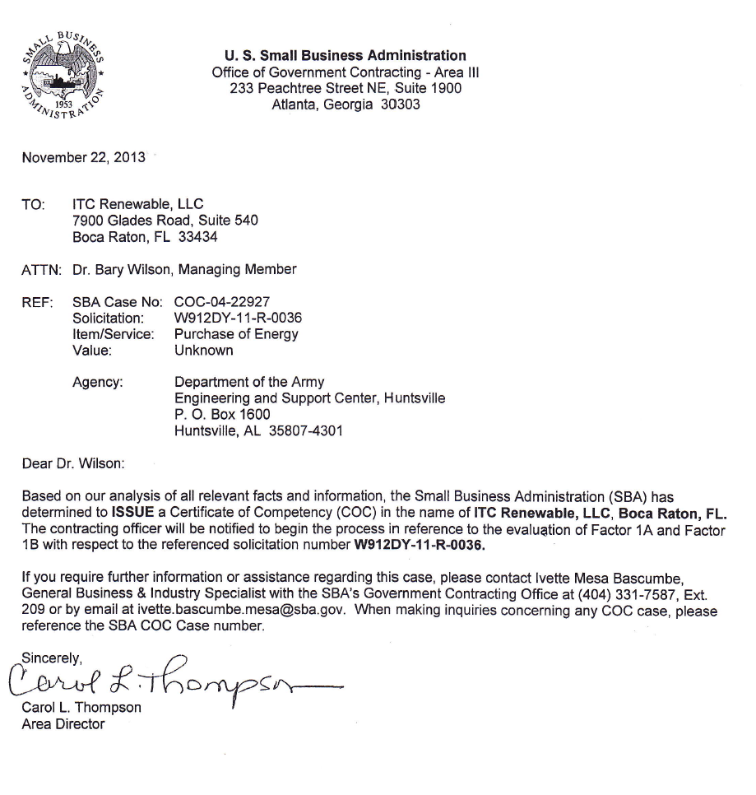

Senior Management Resumes and Credentials:

Broadband Technology Corp (BTC, Consolidated Energy Services Global (CES-G) and ITC Renewable Leadership

President and Chairman, Broadband Technology Corporation, Consolidated Energy Services Global, LLC and IRC Renewable, LLC--- Brigadier General (Retired) Gary G. Harber
BG (Ret) Gary Harber has served in this position from the start of the companys. He is an Army Corp of Engineer Officer and a Master Army Aviator with more than 10,000 hours in military and civilian fixed and rotary wing aircraft. He served as the NATO Northern Regional Wartime Construction Manager and Commander of the 194th Engineer Brigade (Theatre Army). He is the recipient of the Legion of Merit with Oak Leaf Cluster and The Meritorious Service Medal with two Oak Leaf Clusters among other awards. He has served at the Pentagon on numerous occasions to include the Chief, Construction Branch, Army Instillations Division and served on the Chief of Engineers General Officer Executive Council that advised the Chief of Engineers on matters relative to Engineer Unit Requirements and Wartime missions of Engineer units. Council was very involved in Desert Shield/Desert Storm for the employment of engineers. General Harber has a broad range of education, both military and civilian, which has combined to provide the technical understanding and organizational experience needed to respond to the unique needs of the military and Government. Affiliations include the Association on the United States Army; United States Army War College Alumni Association-Class 1982 (Lifetime Member); The Society of American Military Engineers; The Army Engineer Association (Lifetime Member); Military Officers Association of America (MOAA) (Lifetime Member); Order of Daedalians-Military Pilots (Lifetime Member);National Infantry Association (Lifetime Member) and American Legion (Lifetime Member). General Harber’s additional experience related to Army and Military Installation experience is a follows:
- 2nd Army Representative to the Installations Advisory Council
- Chairman, Army Installations Advisory Council
- Army Engineer Member on the National Safety Committee
- Army Engineer Member on the National Environmental Committee
- Army Logistics Mgt. Center, Environmental Executive Course
- Army Logistic Management Center, Managers Environmental CRS.

Department of Defense:
- DoD Joint Services Reserve Component Facility Board-
- Chairman, Joint Services Reserve Component Facility Board\
- Advisor, Facilities Engineer Advisory Council (FEAC)

LTC (Ret) Gary A. Harber CES-G CEO, Consolidated Energy Services

LTC (Ret) Gary A. Harber is the Chief Executive Officer for Consolidate Energy Services. Colonel Harber has extensive experience in both the military and civilian areas. His experience with Boeing includes assignments with Analysis, Modeling, Simulation and Experimentation (AMSE) Division’s Field Office Integration Team at Fort Knox, KY, AMSE CONOPS Team, and Future Combat Systems Manned Ground Vehicles. Work with Boeing has included Business Development, SME Support to the Boeing Product Teams and the International Business Units, Analysis and CONOPS, and Future Combat Systems (FCS) Manned Ground Vehicles. Prior to his employment with Boeing, Gary Harber was a US Army Armor Officer and retired as a Lieutenant Colonel after more than 25 years total military service. His last two assignments with the Army were as the Chief of Concepts and Force Design for the US Army Armor Center at Fort Knox, Kentucky and he was a Theater Level Planner in Korea. Gary’s other Army assignments include Armor, Infantry and staff assignments in a myriad of locations to include Arlington, Virginia and two tours of duty in Korea. Gary holds a Bachelor’s of Science degree in International Relations from Middle Tennessee State University and a Master’s of Arts degree in Political Science from the University of Louisville. His military education included Command and General Staff Officer Course, Combat Developers Course, Armor Officer Advanced Course, Infantry Officer Basic Course, and the US Army Ranger Course. Gary is conversational in the Thai language and can speak basic Korean.

LTC (Ret) Fredrick J. Moll, Vice-President for Government and International Business Development & Managing Partner ITC Renewable.

Colonel Moll joined Consolidated Energy Services Corporation upon its’ founding. His primary role is international business development from the capture planning phase through proposal development and contract award. He also serves as the corporate advisor on US defense acquisition policy and procedures. Mr. Moll served for 22 years in the US Army with a background in acquisition management. He holds a BS in Economics from Widener University and a MS in Management from the University of Utah. His civilian career includes being a Project Manager and regional director of business development in Turkey for General Dynamics Corp. He has also held positions as a Project Manager and defense analyst for both the Camber Corporation and Booz, Allen, Hamilton as well as doing independent consulting work for Boeing Corp., Raytheon Corp., Lockheed Martin Corp., Giat of France and the Camber Corp.

In support of Government project CES-G also utilizes an advisory group composed of prominent and highly experience former Government executives. This advisory group provides support to the board in terms of advice on management decisions and creativity as well as serving as the means to develop interface with current high level DoD decision makers.

PRM Energy Corporation

Ronald W. Bailey, Sr. Chairman

Mr. Ronald W. Bailey, Sr. directed the development and invention of PRM Energy’s King-Chastain gasification technology over thirty years ago. He is still very much involved in the business and advancement of the technology. Among other responsibilities, Mr. Bailey is instrumental in corporate strategy and product development.
After an illustrious career in the rice industry, including as president of one of the world’s largest rice milling companies, Mr. Bailey has dedicated his second career to the advancement of the renewable energy industry and insuring PRM Energy’s place as a leader.
Ron Bailey, Jr., MBA, CPA President

Ron has become the “face” of PRM Energy. As with most entrepreneurs, he wears many hats and spends most of his time traveling or with customers, contractors and partners. Ron’s primary responsibilities are business development, finance and operations; but can often be found at the controls of a new plant where he enjoys the excitement of startups.
Ron’s background includes manufacturing, construction, commodities trading/warehousing, and is a US Army veteran having held a commission in the Corps of Engineers with assignments in combat engineering battalions. Fortunately, all of these experiences have been relevant in his 24 years in the renewable energy industry, particularly the combat engineering.

PAST PERFORMANCE—Broadband Technology Corporation and CONSOLIDATED ENERGY SERVICES GLOBAL

CONSOLIDATED ENERGY SERVICES GLOBAL-BACKGROUND

Consolidated Energy Services Global (CES-G) is a spin-off of Broadband Technology Corporation (BTC), which was also founded by Brigadier General (retired) Gary G. Harber. BTC is comprised of Broadband Technology, Inc. a Service Disabled, Veteran Owned Small Business supporting USAAC and Fort Knox since 2007 and currently supporting USAAC, USACC, and the Armor Center at Fort Knox and Fort Monroe in the Base Re-alignment and Closure Program. The team members include: Broadband Technology, Inc., and Vertical Horizons One, Inc.
Brigadier General (Ret) Gary G. Harber and three other members all of whom are retired Army Officers and have extensive background in Army logistical requirements and international sales founded CES-G to assist the military and other governmental agencies to find tangibles means to reduce energy consumption. Based upon the success and experience he garnered in providing services and products to the US military with Broadband Technologies (BT), the creation of an energy conservation company initially targeting the military market was a logical business decision. In today’s energy conscience business environment the US Government is one of the largest consumers of energy, so by reducing their cost and consumption of energy the entire nation benefits in tax dollars saved.

COMPANY FORMATION AND EXPERTISE

Broadband Technology Corp and Consolidated Energy Services Global (CES-G Global) business headquarters at 4141 82nd Street, Suite 212, Lubbock, Texas, (806) 698-0396 FAX (806) 785-0061the KY Office is at 110 Forest Spring Drive, Elizabethtown, KY.
In addition to helping DoD Installations comply with the federal mandate that military installations move to renewable energy resources and reduce the volume of solid waste going to landfill, this facility would increase energy supply reliability and security by moving energy production "inside the fence". Installation security would also be enhanced by substantial reduction in the number of commercial trucks transits of the gates for hauling sewage sludge and municipal solid waste to landfill.

The U.S. Army Corps of Engineers-Huntsville, AL:
The Huntsville COE is working with the EITF to award the Multi-Award Task Order Contract (MATOC) for procurement of Biomass (WTE) clean energy on DoD Installations as part of a $7 billion contract.

Our Joint Venture Company, ITC Renewable has submitted to the Corp of Engineers MATCO Proposal for Solicitation # W912DY-11-R-0036 Renewable and Alternative Energy (RAE) Biomass Project for a Waste to Energy Biomass PPA and is waiting the issuing of the Task Order for our first project under the contract. The Biomass is the last task order to be issued in the series of task orders.

Task Order Number 0001: Solar PPA

Task Order Number 0002: Wind PPA

Task Order Number 0003: Biomass PPA (waiting award of this TO on the area that was submitted for our companies

BROADBAND TECHNOLOGY CORPORATION / CONSOLIDATED ENERGY SERVICES GLOBAL & ITC Renewable PROJECT EXPERIENCE

Fort Knox:

Company: | Broadband Technology Corp & Teaming Partner of Vertical Horizons One
Project Title/Location: Fort Knox, KY |  |  |  |  |  | W9124D-07-C-0053 Title: Support Services for Office of the Deputy Garrison Commander for Transformation (DGC-T) And Transformation Office And U.S. Army Accessions Command, (USAAC G4/8) Fort Knox, Kentucky, Ft. Knox, KY 40121-5720
Name of Contracting Activity/Owner: |  |  |  |  |  | Army Contracting Agency / U.S. Department of The Army / U.S. Dept. of Defense
Date of Award: |  |  |  | C Contract Term:
Contract Type (FFP/CPAF/etc.): |  |  | Firm Fixed Fee-Labor Hours {Fixed hourly rates Materials at cost}
Contract Value (per year) at Award: |  |  | $644,476.80
Percent of Contract Value (per year) for which your firm is responsible: |  |  |  |  |  |  |  | Project Mgt& QC
Contract Value @ Completion (Indicate # of modifications): |  |  |  |  |  |  |  | $3,497,999.60
Actual Completion Date: |  | 08-31-12 |  |  | Award Date: 2011 |  |  | 8-31-12
Contracting Officer Name, Telephone/Fax number: |  |  |  |  |  |  | Mr. James R. Meeks; 502-624-8438(O)
Program Manager Name, Telephone/Fax number: |  |  |  |  |  |  | COL. Jeffrey S. Ogden; 502-624-2910(O) & Mr. Charles Wilson: 502-626-0709(O) 502-626-1766(F)
Admin Contracting Officer Name, Telephone: |  |  |  |  |  |  | Mr. Richard J. Torres; 502-624-8413(O)
List of Major Subcontractors:
Broadband Technologies, Crop., Lubbock Branch, 6703 82nd Street, Lubbock, TX 79424
Contract Value $
The project was awarded to Vertical Horizons One with Teaming Partner Broadband Technology Corp
Provide the functions performed by your firm and describe the relevance of this project to the solicitation:
VHO is teamed with Broadband Technologies Corporation, (BTC) on this effort. BTC is a Veteran-Owned Small Business headquartered in Nashville, Tennessee. The President is BG (Ret.) Gary G. Harber. Established in May 2001, BTC’s objectives and strategy have been to provide its customers with alternatives to the standard way of doing business – that is, BTC gives customers the respect, quality and satisfaction they require and deserve. BTC focuses on emerging Armed Services needs and provides products, services and solutions using the latest technologies from commercial industry. Broadband Technology Corp served as the PM and QC for the project
Describe the problems encountered by your firm & the corrective actions taken:
None
Awards:
GSA Audit Broadband Technology Corp received the OUTSTANDING rating with all areas of the contract in compliance. There were no areas of the report that did not comply with GSA requirements and regulations.

Tennessee National Guard:

Company: | Broadband Technology Corp
Project Title/Location: TN ARNG |  |  |  |  | W912L7-04-F-0119 Ortho-imagery for the TN Army National Guard
Name of Contracting Activity/Owner: |  |  |  |  | USPFO for TN
Date of Award:17 May 2004 |  |  |  |  |  | Contract Term:
Contract Type (FFP/CPAF/etc.): |  |  |  |  |  |  | GSA Schedule 35F0813M
Contract Value (per year) at Award: |  |  |  |  |  |  | $130,421.00
Percent of Contract Value (per year) for which your firm is responsible:FY04-FY05 |  |  |  |  |  |  |  |  | 100%
Contract Value @ Completion (Indicate # of modifications): |  |  |  |  |  |  |  |  | $151,437.70
Actual Completion Date: |  | Feb 3, 05 |  | Award Completion Date: |  |  |  |  | Initial 6 Months extended by CO to 9 Months
Contracting Officer Name, Telephone/Fax : |  |  |  |  |  |  |  | Mr. Sammy K. Beard 615-313-2650 Contracting Officer, USPFO for TN
Program Manager Name, Telephone/Fax number: |  |  |  |  |  |  |  | Mr. Carman Roberson (615) 313-2621
Admin Contracting Officer Name, Telephone/Fax number: |  |  |  |  |  |  |  | Mr. Carman Roberson 615-313-2621
List of Major Subcontractors: Scientific Data Strategies-SDS
Provide the functions performed by your firm and describe the relevance of this project to the solicitation:
Broadband Technology Corp: The scope of work is as follows: Contractor shall acquire new aerial photography of selected sites (all TNARNG Armory and Logistical Sites throughout the State of Tennessee) (Red-dot and Orange-dot sites) and process them into true color, digital ortho images capable of supporting 1”:100’ scale mapping, .3 meter resolution or better with 2 meter contours. Sites coded as blue dots are presumed to be covered by existing 1”:100’ scale ortho-imagery from the TNBMP project and will be provided in addition to the Red and Orange Dot Sites as part of the total Statement of Work. All aerial photography will be provided to the TNARNG, GIS Branch on CD which are in non-read only format so that the TNARN may have full read, write and edit capabilities, owning all rights and privileges to this information. All data will be provided in a SDS/FIE compliant format with all FGDC compliant metadata files completed and attached.
Site locations will be provided by the TNARNG for Contractor comparison against TNBMP status information to determine the level of need for new photography. In the following map, sites coded as blue dots are presumed to be covered by existing 1”:100’ scale ortho-imagery from the TNBMP project. Sites coded as orange dots are in counties that have TNBMP activity, but no 1”:100’ scale ortho-imagery at that exact location. Orange dots are presumed to be covered by smaller-scale ortho-imagery, most commonly prepared for 1”:400’ scale mapping. Finally, sites coded as red dots are presumed to be without any TNBMP imagery.
Describe the problems encountered by your firm & the corrective actions taken:
None
Awards:
GSA Audit Broadband Technology Corp received the OUTSTANDING rating with all areas of the contract in compliance. There were no areas of the report that did not comply with GSA requirements and regulations.

Tennessee Army National Guard-Environmental Division:

Company: | Broadband Technology Corp
Project Title/Location: |  |  |  | Developing A Web-Based Reporting System Integral to the Environmental Management System (EMS)
Name of Contracting Activity/Owner: |  |  |  | TN ARNG Engineer office
Date of Award: |  |  | 09/03/04 |  | Contract Term: |  |  | Base Year plus 4 Optional years
Contract Type (FFP/CPAF/etc.): |  |  |  | GS35F-0813M Order No. W912L7-04-F-0257
Contract Value (per year) at Award: |  |  |  | $ 8,915.00
Percent of Contract Value (per year) for which your firm is responsible: |  |  |  |  |  |  |  |  | 100%
Contract Value @ Completion (Indicate # of modifications): |  |  |  |  |  |  |  |  | $8,915.00
Actual Completion Date: |  | 11/31/2005 |  |  |  | Award Completion Date: |  |  | 11/17/2004
Contracting Officer Name, Telephone/Fax number: |  |  |  |  |  |  | LTC Tony Funderburg (615) 313-0606  FAX:615-313-0757
Program Manager Name, Telephone/Fax number: |  |  |  |  |  |  | LTC Tony Funderburg (As Above)
Admin Contracting Officer Name, Telephone/Fax number: |  |  |  |  |  |  | LTC Tony Funderburg (As Above)
List of Major Subcontractors:
None
Contract Value $ 8,915.00
Provide the functions performed by your firm and describe the relevance of this project to the solicitation:
Broadband Technology Corp served as the contractor for the project utilizing our GSA Schedule 70 Contract No GS35F-0813M and provided contract management, administration and implementation of the project to include training of personnel in the utilization of the system.
Describe the problems encountered by your firm & the corrective actions taken:
None
Awards:
GSA Audit Broadband Technology Corp received the OUTSTANDING rating with all areas of the contract in compliance. There were no areas of the report that did not comply with GSA requirements and regulations.

Cratech Inc.: Mr. Joe Craig, President
Mr. Craig began his career as a design engineer for the power plant research division of Caterpillar, Inc. He left Caterpillar to advance his passion for developing and commercializing processes to economically convert biomass into power, fuels and chemicals. He founded Cratech n 1990. He has since lead the development of the company’s new generation of small scale biomass fueled power plants. Mr. Craig owns three patents on the process.
Mr. Craig is a professional engineer who has developed technical and financial models for evaluating various types of biomass fueled power projects. These models allow him to quickly evaluate and assess a site’s potential for economical and clean production of renewable energy from biomass and other organic waste streams.
Mr. Craig is a highly experienced designer of innovative and adaptable gasification systems. His more than 40 designs have been used for applications ranging from coal to biomass and for the production of both steam and electrical power. Mr. Craig has developed engineering design models that allow the quick and accurate assessment of design variables. This model allows the adaptation and scaling of gasifier designs to the fuel types and fuel quantities available allowing BTC to tailor Waste to Energy plant to not only the customer’s requirements, but also to the availability of the most economically viable local Refuse Derived Fuels.

Mr. Joe Nevill, Senior Engineer and Project Manager
Mr. Nevill has experience in process control programming, design and procurement. Project management, mechanical design and engineering. Gearing and mechanical power transmission systems, mathematical modeling, materials and metallurgy, complex system diagnostic capabilities, general mechanical manufacturing and fabrication. He has a master of science degree in mechanical engineering.
He is also experienced with electric motor and elecro-mechnical systems, their design, application, procurement and installation.
Mr. Nevill also owns and manages an irrigated farm growing cotton, peanuts and milo. He has experience in developing, constructing, operating and maintaining farm scale wind power systems.

Mr. Steve Stone, Business Development
Mr. Stone begin his professional experience as a contracts engineer with General Electric. He is a degreed and professional Industrial engineer. He was the first engineer hired to help develop a unique type of hydraulic motor for a startup company. Following many years of development effort and company growth Steve helped sell and transfer the hydraulic motor technology to the Danfoss company. Once the technology was transferred, Steve left to pursue other interest and has now been working for Cratech many years. Steve manages business contacts, advises on business strategy, and works with general counsel to negotiates contracts.

Past Experience Cratech
Cratech developed its power process over a period of years beginning in 1990. It received and match funded (with private investment) several grants and contracts. Among these contracts were:
Project Title: Development of a biomass fueled integrated gasifier/gas turbine power plant
Contract no. TV-92261V
Customer: Tennesee Valley Authority. P.O. Box 1010, Muscle Shoals, AL 35660
Time frame: 1993 to 2001
Amount: $594,000

Project Title: High temperature filter vessel for a Small Scale Biomass-fueled integrated-
Gasifier Gas Turbine (BIGGT) power plant
Cooperative Agreement with US EPA no. CR 817675-01
Customer: State of Vermont, Department of Public Service 120 State Street
Montpelier, VT 05620-2601
Time frame: 1995 to 2001
Amount: $195,038

Project Title: Phase II Biomass Gasifier Development
contract no. DE-FC65-96WA13475
Customer : US DOE Western Area Power Administration
P.O. Box 3402 Golden, CO 80401
Time frame: 1996 to 1999
Amount: 158,500

The most knowledgeable person familiar with these development efforts is:
Carol Purvis US EPA
Research Triangle Park, NC 27711

PAST PERFORMANCE-- ITI GROUP

ITI GROUP--BACKGROUND
ITI Group is comprised of environmental services and engineering companies that provide design, construction, and operation of Waste to Energy, and Coal Fly Ash services throughout the United States and internationally. The senior professionals of ITI Group have extensive experience in the areas of environmental, geotechnical, structural, and civil engineering, solid, hazardous, and radioactive waste management, waste gasification, fly ash conversion to supplemental cement materials, hydrology, and hydrogeology, and water and wastewater systems. The ITI professional staff has advanced degrees from some of the world’s most prestigious schools, is well-published, world renown in its areas of expertise, and highly involved in many professional organizations.
ITI personnel have completed more than 250 solid waste management projects in many countries throughout the world. These projects have included the design, permitting, construction, and/or operation of Waste Gasification Facilities, MSW and hazardous waste landfills, sorting facilities, compost plants, transfer stations, leachate treatment facilities, landfill gas to energy facilities, and medical and hazardous waste treatment facilities.

COMPANY FORMATION AND EXPERTISE
Dr. Neil D. Williams, P.E., of ITI is one of the developers of geosynthetic lining systems for landfills, and was the designer and project manager of the first landfill constructed using a geosynthetic lining system. Dr. Williams has more than 50 publications on landfill design using geosynthetic lining systems. Mr. Roberts has managed the design, construction, and operation of 15 solid waste management facilities and two thermal treatment facilities in Florida, USA. Brief summaries of several key landfill projects that were similar in scope and size to the Bahamas 30 MW Gasification Facility project are presented below.
The companies that comprise ITI Group are as follows:
- Innviron Corporation is a Florida Corporation with offices in Coral Springs and Naples, Florida. Innviron Corporation designs, constructs, and operates solid waste management facilities, including Sorting Facilities, Gasification Facilities, Construction and Demolition Debris (C&D) Processing Facilities, C&D Landfills, Municipal Solid Waste (MSW) Landfills, Hazardous Waste (HW) Landfills, HW Treatment Facilities, Transfer Stations, and Medical Waste Treatment Facilities. Innviron is the parent company of ITI.

- TensorCrete, LLC is a Delaware Corporation with main Offices in Fort Lauderdale Florida. TensorCrete develops and deploys high temperature gasification-based processes for the conversion of carbonaceous materials, especially coal combustion products, to energy and cementitious materials used in concrete. ITI currently holds a worldwide exclusive license for the commercial deployment of TensorCrete proprietary waste to energy technologies.

- Innviron Argentina, S.A., is an Argentina Corporation with offices in Buenos Aires and Carlos Pas. Innviron Argentina is a solid waste operating company, has purchased Cotreco, and currently operates a solid waste collection company in Carlos Pas, Argentina.

- Medio Ambiente is an Argentina Corporation with offices in Villa Maria, Argentina, with more than 17 years of experience in collection, transport, treatment, and disposal of MSW. Medio Ambiente currently collects approximately 500 tonnes/day of MSW in three major cities in Argentina.

- Globex Engineering International (Globex) is an affiliated engineering and operating company with corporate headquarters in Beirut, Lebanon, specialized in water resource development, water treatment, dam design and construction, wastewater treatment, and solid and hazardous waste management. Globex has offices in Algiers, Algeria, Beirut, Lebanon, and Muscat, Oman.

The experience and qualifications of the ITI professionals in solid and hazardous waste management are second to none. ITI professionals have provided solid waste operations management at more than 50 facilities worldwide, and have provided design and management services on more than 250 solid waste management projects, including gasification facilities, landfills, compost plants, sorting facilities (materials recycling facilities), medical waste treatment facilities, transfer stations, hazardous waste treatment facilities, and hazardous waste disposal facilities. In addition, ITI has extensive experience in the design, construction, and operation of leachate and wastewater treatment facilities, water treatment facilities, including desalination facilities, landfill gas to energy facilities, and waste gasification facilities.

ITI has developed proprietary systems for Gasification of MSW, conversion to energy, and processing of the slag and ash from coal combustion into supplemental cement materials (SCM). The integrated Waste Gasification System developed by ITI and its affiliates operates at a very high efficiency, produces energy at a low cost, and has the lowest flue gas emissions concentrations in the industry. In fact, the flue gas emissions from the ITI Gasification System are several orders of magnitude lower than USEPA standards, resulting in the classification of the ITI Gasification System as a Green Technology, and a Renewable Energy Resource.

ITI was founded to serve clients in the waste to energy, coal fly ash conversion, waste management, water resources, wastewater treatment, and infrastructure development areas using innovative and cost-effective technologies. ITI is committed to providing the highest levels of service, providing high quality deliverables, and meeting our clients time and budget requirements. ITI’s commitment to excellence is demonstrated by its more than 85 percent repeat business with its existing clients, its ability to deliver projects on time and under budget, and its ongoing efforts to develop and implement innovative and cost-effective technologies for Waste Gasification.

ITI and its senior staff have:

- Designed more than 250 solid waste management facilities, including landfills, leachate and gas treatment systems, landfill gas turbine installations, transfer stations, sorting facilities, incinerators, waste gasification facilities, landfill gas power fuel systems, and medical waste treatment facilities;
- Managed construction of more than 100 solid waste facilities;
- Assisted in development of RCRA regulations, developed the geosynthetic lining system technologies, and developed sorting facility and composting system technologies;
- Assisted in development of RCRA regulations, developed the geosynthetic lining system technologies, and developed sorting facility and composting system technologies;
- Developed solid and hazardous waste management regulations for many countries and several states;
- Designed, constructed, and/or operated solid waste facilities in the USA, Argentina, Ecuador, Oman, Lebanon, Panama, Turkey, and the UAE;
- Published more than 100 papers on Solid and Hazardous Waste Management;
- Provided Expert Services for Permitting of the only Hazardous / Transuranic Waste Repository in the USA (WIPP Facility).
- ITI professionals have established a reputation of excellence by providing engineering services throughout the United States (including Puerto Rico and the U.S. Virgin Islands), Algeria, Argentina, The Bahamas, Bahrain, Bangladesh, Belgium, Bolivia, Brazil, Canada, China, Costa Rica, Ecuador, Egypt, Eritrea, Iraq, Jordan, Lebanon, Nigeria, Oman, Pakistan, Panama, Portugal, Qatar, Saudi Arabia, Sri Lanka, St. Lucia, Syria, Turkey, and the UAE.

ITI PROJECT EXPERIENCE

LAND FILL, DESIGN, CONSTRUCTION AND OPERATION
122nd Street Solid Waste Management Facilities
Chicago, Illinois, USA
Client: Land and Lakes Company

The 122nd Street Solid Waste Management Facilities include a landfill, leachate treatment facility, MSW Landfill, and HW Treatment Facility, and surface impoundment. The facility includes an active 50-acre (20-hectare) municipal solid waste landfill located in Chicago, Illinois, owned and operated by Land and Lakes Company (LALC). The services provided to LALC at the 122nd Street Landfill include: represented client in public hearings; designed and permitted a closure plan for the facility; prepared closure and post-closure care cost estimates; designed and permitted a double-lined leachate storage pond; designed and permitted a Class I landfill cell; prepared a regulatory mandated permit application to upgrade the landfill operations to meet the current rules; designed a surface-water management system for the entire facility; designed a leachate management system which included a leachate extraction and conveyance system for the existing facility; prepared a ground-water monitoring plan; prepared an operating plan for the facility; provided QA/QC monitoring services for the construction of clay and geosynthetic components of the lining system; represented LALC on numerous occasions in meetings with IEPA; and prepared and evaluated bids for construction of a gas-to-energy system. The design capacity of the landfill was approximately 2,000 tons/day.
Countryside Landfill And Solid Waste Management Facilities
Grayslake, Illinois, USA
Client: USA Waste Services, Inc.

As the Engineer-of-Record for the Countryside Landfill facility, ITI personnel were involved in every technical aspect of the operations and development at the site. A landfill siting approval was obtained as part of the future expansion of the landfill, which was a major accomplishment in the northern Illinois. The siting application prepared by others had previously been denied on two separate occasions. Following the siting approval, a permit application was submitted to the Illinois Environmental Protection Agency (IEPA) for review and approval. The permit was approved within eight months of the date of submittal. To complete the permitting process, eight other permit applications were submitted to various federal, state, and local regulatory agencies. All necessary permits for the development of the landfill expansion have been issued and the expansion construction is presently in progress.

The following activities were among the major accomplishments in the course of this project: met with adjacent property owners during planning phases and worked with landscape architect to address community concerns; designed, permitted, and constructed an innovative intermediate cover to address odor problems; designed and obtained siting approval for the future expansion; designed, permitted, and constructed an innovative passive gas collection system; designed, permitted, and constructed a dual leachate/gas extraction system; participated in the preparation of a wetland mitigation permit application to the USACOE; designed a wetland mitigation plan that included the creation of 100 acres (40 hectares) of new wetland; prepared a new operations plan which included landfilling in a double-lined facility equipped with leachate collection, leachate recirculation, gas collection, gas disposal flares, and a leachate treatment system; coordinated a waste stream need analysis, required for siting the project; coordinated design of an expansion of a state highway adjacent to the landfill; designed, permitted, and constructed a leachate control trench around the existing landfill to prevent seepage of leachate into the landfill expansion; designed and permitted a barrier wall along one side of the property to protect the site against seepage from an abandoned landfill on the adjacent property; designed and permitted a surface-water management system for the site which involved flood-proofing the future expansion areas that are presently within the 100-year floodplain and revised the applicable FIRM plans prepared by FEMA; prepared construction drawings for each phase of construction; and provided QA/QC monitoring services and construction management. The Countryside Landfill was designed to process up to 10,000 tons/day of MSW.

Glossary of Terms and Acronyms

Base load: electrical load on a generating system that is equal to its rated power output.
Base load plant: electrical generating plant that provides a constant flow of power regardless of the power demand of the grid.
Biomass: “Biomass” for purposes of this proposal means all technologies that utilize organic material to generate a fuel or energy such as, but not limited to, Biomass-to-Power, Waste to Energy, Refuse Derived Fuels and methane fuel generated by landfills, etc.”
Bio-solids: solid material remaining after the processing of wastewater / solid or semisolid constituents of sewage.
BTU: British Thermal Unit; a unit of energy equal to 1.06 kilojoules.
C&D Waste: construction and demolition waste.
CEMS: Continuous Emissions Monitoring Systems
CHP: Combine Heat and Power similar to cogeneration.
CO: Contracting Officer
COCO: Contractor Owned Contractor Operated
Combined Cycle: power plant or engine that employs more than one thermodynamic cycle.
COR/COTR: Contracting Officer's Representative
COTR: Contracting Officer's Technical Representative
COTS: Commercial Off-the Shelf
DoD: Department of Defense
DPW: Department of Public Works
EPC: Engineering Procurement Contractor
ESP: Electrostatic Precipitator
GTCC: gas turbine combined cycle (equivalent to combined cycle gas turbine, or CCGT)
GT/GHCC: gas turbine / gasifier combined cycle (hybrid power plant wherein steam is produced in boilers heated by both gas turbines and gasifier syngas to drive steam turbine generators.
Gasification: thermal process whereby organic materials are converted to a fuel gas (producer gas or syngas) at high temperatures in oxygen starved environment.
ITCR: BTC, Joint Venture, LLC
kW: kilowatt (a unit of power equal to 1000 watts).
kW-h : amount of energy required by a load of thousand watts for a period of 1 hour (equal to 3.6 mega joules).
MSW: municipal solid waste.
MW: one million watts of power.
MW-h: amount of energy required by a load of one million watts for a period of 1hour.
Peak shaving: the process of providing additional power to the grid during periods of high demand.
Peaking units (or peak shavers or peaking generators): commonly single cycle gas turbine generators that can be operated for intermittent periods to “shave” the peaks in power demand.
PM: Project Manager
PPA: Power Purchase Agreement
RDF Refuse Derived Fuel.
ROI: Returns on Investment
Syngas: short for “synthesis gas”, a fuel gas composed mainly of hydrogen, carbon monoxide, carbon dioxide and methane.
Tipping Fees: Those fees paid by a waste hauling company to a landfill operator for accepting waste.Normally, paid in amounts of dollars per ton, with fees varying greatly from location to location.
WTE: Waste to Energy

PAYMENT
Payment shall be made upon submission of a proper invoice. A proper invoice is defined as containing the contract number and itemization of amounts requested. Invoices will be submitted to the VA Point of Contract as shown in the contract for approval and forwarded to the appropriate financial management office for payment as shown below.
Payment Address:
Direct Payment:
Broadband Technology Corp
Attn: Accounts Receivable
3212 West End Avenue, Suite 500
Nashville, TN 37203-1365
Electronic Fund Transfer or ACH Payment Information:
Bank: Bank of America
Route #: 064000020
Account #: 3786555711

Automated Clearing House (ACH)
U.S. Phone: (615) 291-2890

This assumes of course that BTC will receive an approved Power Purchase Agreement from the US Government NLT the fall of 2014 as it will require approximately 18 to 24 months, to design, permit, build and commission the plant.
Note: Land belonging to the Federal Government will be licensed to the BTC Team in accordance with USAF Regulations.
Also referred to as a "bankruptcy-remote entity" whose operations are limited to the acquisition and financing of specific assets. The SPV is usually a subsidiary company with an asset/liability structure and legal status that makes its obligations secure even if the parent company goes bankrupt.
Nameplate refers to total generating capability of the module to include the 3MW consumed because of parasitic power. The total power provided to the grid by each module is 9 MW.
Also referred to as a "bankruptcy-remote entity" whose operations are limited to the acquisition and financing of specific assets. The SPV is usually a subsidiary company with an asset/liability structure and legal status that makes its obligations secure even if the parent company goes bankrupt.
objectives -- "to procure reliable locally generated renewable and alternative energy (RAE) utilizing Power Purchase Agreements (PPA) or other contractual equivalents. The intent of the Government is only to purchase the energy that is produced and not to acquire any generation assets. The Contractor shall develop, finance, design, build, operate, own and maintain the energy plant".
Also referred to as a "bankruptcy-remote entity" whose operations are limited to the acquisition and financing of specific assets. The SPV is usually a subsidiary company with an asset/liability structure and legal status that makes its obligations secure even if the parent company goes bankrupt.

